**Aldabra Research Station**

**Research Officer’s Annual Report**

**2008**

Compiled by: Naomi Doak

Naomi Doak (PhD)

Research officer

Aldabra Research Station

Seychelles Islands Foundation

research@sif.sc

# Contents

List of Figures 1

List of Tables 2

1.0: Summary 3

2.0: Climate 6

3.0: Turtle Monitoring 8

3.1: Track counts along external beaches (Green turtles) 8

3.2: Track counts along lagoon beaches (Hawksbill turtles) 10

3.3: Tagging of Nesting Turtles 10

3.4: Tagging of juvenile turtles 11

4.0: Aldabra Tortoise Monitoring Programme 11

5.0: Bird Monitoring 15

5.1: Land birds 15

5.2: Wader counts 19

5.3: Sea birds 26

6.0: Butterfly fish monitoring 27

7.0: Subsistence Fishing 28

8.0: Robber Crabs 31

9.0: Marine Mammals 33

9.1: Dugongs 33

9.2: Whales and dolphins 33

10.0: Vegetation Monitoring 35

11.0: Goat Eradication Project 37

12.0: Departmental Issues 44

12.1: Staff 44

12.2: Rangers Projects 45

12.3: Volunteer Projects 45

12.4: Visiting Scientists 47

12.5: Visiting Vessels 49

12.6: Poaching reports 50

12.7: Logistics / Incident reports 50

13.0: Publications 50

14.0: Appendices 51

# List of Figures

**Figure 1:** Map of Aldabra Atoll with camps and locations of monitoring transect/activities. 7

**Figure 2:** Total Monthly Rainfall and Average Maximum Temperature for Picard. 9

**Figure 3:** Total annual rainfall 2005 – 2008 and mean monthly rainfall around the atoll. 9

**Figure 4:** Average monthly number of emergence tracks recorded on settlement beach. 11

**Figure 5:** Number of individuals and mean size for tortoise transects at Picard. 13

**Figure 6:** Number of individuals and mean size for tortoise transects monitored on Malabar. 14

**Figure 7:** Number of individuals and mean size for tortoise transects at Cinq Cases. 15

**Figure 8:** Number of individuals and mean size for tortoise transects on Grande Terre, Dune Jean Louis and Dune D’Messe. 15

**Figure 9:** Total number and monthly mean number of birds recorded on all transects. 17

**Figure 10:** Mean annual total and total number of land birds recorded for each species. 17

**Figure 11:** Total number of land birds recorded for each species. 18

**Figure 12:** Species composition and relative abundance of migratory waders on Settlement Beach. 20

**Figure 13:** Mean number of individuals of wader species recorded along Settlement beach 21

**Figure 14:** Species composition and relative abundance of migratory waders on Grande Terre 22

**Figure 15:** Abundance of Crab plovers along Settlement Beach. 23

**Figure 16:** Abundance of Crab plovers in relation to tide height along Settlement Beach. 24

**Figure 17:** Total weight of bottom fish caught each month in 2008. 29

**Figure 18:** Total weight of trawled fish caught each month in 2008. 29

**Figure 19:** Mean abundance and size of coconut crabs along the back path. 31

**Figure 20:** Mean abundance and size of coconut crabs along the coastal path. 31

**Figure 21:** Killer whales photographed in the waters adjacent to Aldabra 33

**Figure 22:** Staff conducting GEP activities and 2 adult female non-judas goats. 37

**Figure 23:** Map of the locations of Goat Sightings for 2008. 38

# List of Tables

**Table 1:** Mean monthly temperatures for 2008, Picard weather station. 8

**Table 2:** Turtle tracks observed on Settlement Beach 10

**Table 3:** Mean monthly number of turtle tracks observed for all beaches around the Atoll 12

**Table 4:** Yearly total for Aldabran rails recorded on land bird transects. 19

**Table 5:** Total number of Rails recorded on land bird transects each month. 19

**Table 6:** Wader species identified on fewer than 6 monitoring occasions on Settlement Beach. 21

**Table 7:** Wader species identified on only 1 occasion at Dune Jean-Louis to Dune D’Messe. 22

**Table 8:** Monthly counts of crab plovers. 24

**Table 9:** Details of sightings of flamingos. 25

**Table 10:** Details of sightings of vagrant and unusual bird species. 26

**Table 11:** Species and abundance of butterfly fish recorded on the monitoring transect. 27

**Table 12:** Details of fishing trips conducted throughout 2008. 28

**Table 13:** Plant species included in the vegetation phenology monitoring. 35

**Table 14:** Summary of Goat Eradication Project activities for October – December 2008. 39

**Table 15:** Name, position and engagement of research staff at the Aldabra Research Station. 41

**Table 16:** Vessels visiting Aldabra research Station. 46

# 1.0: Summary

As I am a relatively new research Officer on Aldabra and I commenced working in this position at the end of November 2008, the following Annual Report has been compiled from my time here in the last 2 months in 2008, the limited number of monthly reports completed during 2008 and from the data bases present at the station.

It has been a difficult time over the last year trying to keep the monitoring programmes on track. This has been influenced by boat and engine problems and the heightened tourist activity on the atoll in the last few months of the year. It was also due to the (double) change of Research Officer which included a number of months when there was no research officer on the atoll which has unfortunately meant that the monitoring programmes have had to take a back seat and monthly reports were often not completed. Since my arrival I have done my best to catch up on monthly reports for the last three months of the year and to continue with comprehensive and timely reports for the start of 2009.

During 2008, despite the staff changes and the absence of a Research Officer for some months meteorological data (temperature and rainfall) was collected at the research station on a daily basis and monthly rainfall totals were collected for all rain gauges around the atoll (Figure 1). As in previous years a considerable proportion of the time spent undertaking monitoring activities on the atoll was dedicated to collecting valuable data on turtles. This included emergence counts for nesting green and hawksbill turtles, tagging of nesting green turtles, emergences of nesting hawksbill turtles, and juvenile green and hawksbill turtles in the lagoon. A volunteer project commencing in November also investigated the number and distribution of foraging turtles in the lagoon and revealed some interesting trends in the sex ratio of foraging turtles on the sea grass beds in the lagoon area behind Picard. Twice monthly assessments of beach accessibility were also undertaken along Settlement Beach as part of the turtle monitoring conducted on the atoll.

Monthly data was collected for all the tortoise transects and land bird point counts in various locations around the atoll (Figure 1). Twelve transects are monitored for tortoises and seven of these are also used for the land bird point counts with the number of points on each ranging from four to nine. Monitoring of birds on the atoll is not restricted to the land birds and counts of the number and species of waders are also carried out. These were primarily completed along settlement beach on Picard at least twice every month with counts also being conducted along the coast from Dune Jean-Louis to Dune D’Messe when possible once a month. When possible counts of the number of crab plovers were conducted at Ile Moustique and the red-tailed tropic birds nesting on the islets on the inside of the lagoon adjacent to Picard were also monitored for nesting activity. For the first time on the atoll targeted surveys and a specific project investigating the presence of the Madagascar pond heron commenced to coincide with the reported breeding period for this species on the atoll.

In April 2007 vegetation monitoring was initiated along the back path on Picard and this was continued into 2008. Focusing on the phenology of common species along the transect this monitoring activity underwent a number of changes during 2008 but continues to gather important information on the vegetation and observations of interactions between potential pollinators as well as species feeding on the vegetation. Considerable time and effort was also spent throughout the year monitoring the number and size of coconut crabs along the back path and coastal path tortoise transects on Picard. This monitoring was conducted 2 – 4 times a month and continues to provide large amounts of data on the abundance, size and distribution of coconut crabs along these two transects.

While the majority of monitoring programmes on the atoll concentrate on the terrestrial environment a number of marine monitoring programmes were conducted and continued in 2008. The transect first established by the AMP opposite the settlement at the research station was monitored for butterfly fish species presence and abundance on numerous occasions throughout the year and data on fish catches was collected following all subsistence fishing. Observations of whales, dolphins and dugongs were also recorded and provide valuable information on the species frequently sighted around the atoll as well as the seasonality of particular species.

2008 was a busy year on Aldabra in terms of monitoring activities, staff changes and also visitors. An increase in tourist activity saw the final months of the year pass with days busy with tour groups and cruise ships. It was also a busy year in terms of visiting researchers with numerous groups arriving on the atoll to conduct important research on a wide variety of projects including the SOPTOM Expedition with 10 French scientists, a delegation of researchers from the IUCN investigating reef resilience, a group from the Save Our Seas Foundation, a group collecting mosquitoes and other biting insects and sample collection from the bat populations on the atoll. The year also welcomed another visit from the AMP to conduct surveys and monitoring at established sites around the atoll.

The following report provides a summary of the data collected in the numerous monitoring activities around the atoll while also providing some basic analysis of this data.

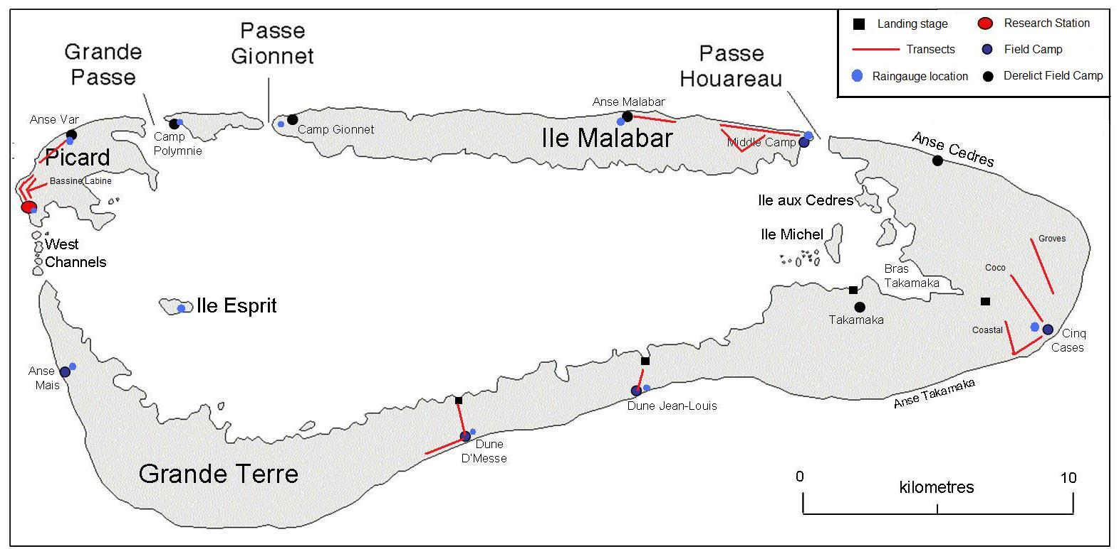

**Figure 1:** Map of Aldabra Atoll with camps and locations of monitoring transect/activities.

# 2.0: Climate

Daily temperature readings are taken from the Stevenson Screen at the station. These include dry and wet bulb temperature at 8:00 am in the morning, when all readings are taken, and the maximum and minimum temperatures for the previous 24 hours. Mean monthly temperatures based on these daily readings are provided in Table 1. Note that late in October a giant tortoise knocked over the Stevenson screen breaking all the thermometers and requiring a replacement screen to be sent from Mahé. No temperature readings were possible during this time and the replacement minimum thermometer was also damaged and no recordings could be made in December for this parameter. Perhaps the most informative of these readings is the maximum daily temperature which gives an indication of the warmest temperature experienced at the station. For this reason the maximum temperature recorded throughout each month is also included Table 1. Any overall increase in temperatures at the station will be reflected in an increase in the maximum temperature recorded each day as well as the overall mean maximum temperature. While any comparison between maximum temperatures is relatively meaningless over short temporal periods both of these parameters for 2007 have been included in this report to provide a comparison in any trends as far as the hottest months of the year. In 2008 the months of January, February and March all recorded the highest mean maximum temperature while in 2007 these three months recorded the lowest mean maximum temperature with December recording the highest mean for 2007.

Table 1: Mean monthly temperatures for 2008, Picard weather station.

|  |  |  |  |  |  |  |  |  |  |  |  |  |
| --- | --- | --- | --- | --- | --- | --- | --- | --- | --- | --- | --- | --- |
| **2008** | **Jan** | **Feb** | **March** | **April** | **May** | **June** | **July** | **August** | **Sept** | **Oct** | **Nov** | **Dec** |
| dry bulb | 27.7 | 27.7 | 27.6 | 27.3 | 26.8 | 25.3 | 24.3 | 24.6 | 25.4 | 26.5 | NA | 28.9 |
| wet bulb | 26.8 | 26.5 | 26.3 | 26.2 | 24.9 | 23.8 | 22.7 | 22.8 | 23.7 | 24.7 | NA | 26.9 |
| daily max | 35.5 | 35.5 | 35.5 | 32.8 | 31.6 | 29.5 | 28.6 | 28.5 | 29.6 | 30.6 | NA | 32.8 |
| daily min | 25.9 | 25.8 | 25.7 | 25.3 | 25.2 | 23.6 | 17.6 | 18.2 | 18.6 | 19.4 | NA |  |
| Max daily maximum | 35.8 | 35.5 | 35.5 | 35.5 | 31.6 | 33.0 | 33.0 | 29.5 | 30.6 | 32.1 | NA | 34.8 |
|  | |  | | | | | | | | | | |
| **2007** |  |  |  |  |  |  |  |  |  |  |  |  |
| mean max | 33 | 33.21 | 33.6 | 35.14 | 35.22 | 35.37 | 35.31 | 35.37 | 35.4 | 35.37 | 35.4 | 35.5 |
| Max daily maximum | 33.1 | 33.5 | 34.8 | 35.5 | 35.5 | 35.5 | 35.4 | 35.4 | 35.4 | 35.5 | 35.5 | 35.5 |

Daily rainfall data is also collected at the research station. Figure 2 shows the total monthly rainfall for each month of 2008 as well as depicting three of the temperature variables collected each day. January was by far the wettest month of the year in 2008 with the highest total monthly rainfall. As mentioned above January was also one of the three months that experienced the highest mean maximum temperature (35.5oC) as well as recording the day with the highest maximum temperature (35.8oC). In contrast to the high rainfall recorded in January, October recorded the lowest rainfall for the year. This is similar to 2007 when October also recorded the lowest rainfall.

Rainfall totals vary considerably around the atoll and there is no obvious or consistent pattern in the amount of rainfall that falls each month across the 12 locations where rainfall is recorded. Figure 3 shows the monthly rainfall recorded at these 12 locations. It shows the total rainfall for the past four years while also showing the mean monthly rainfall recorded at each location for 2008. In 2008 Middle Camp recorded the highest total amount of rainfall as well as the highest mean monthly rainfall. This is unlike previous years where Middle Camp often recorded the lowest total rainfall (e.g. 2006).

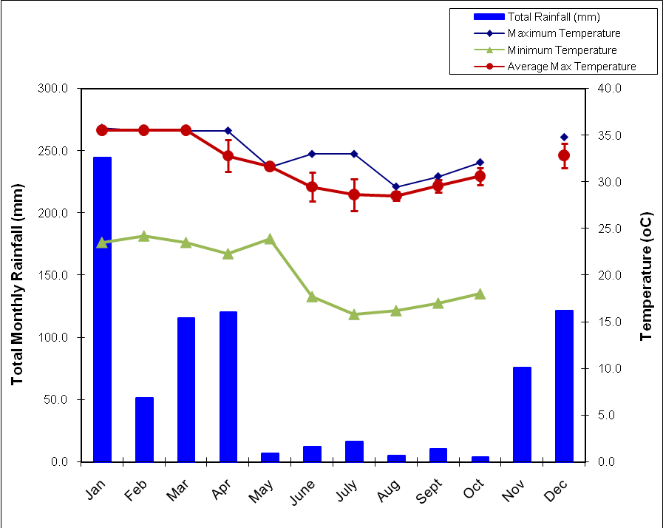

**Figure 2:** Total Monthly Rainfall and Average Maximum Temperature for Picard, Aldabra (error bars are standard deviation).

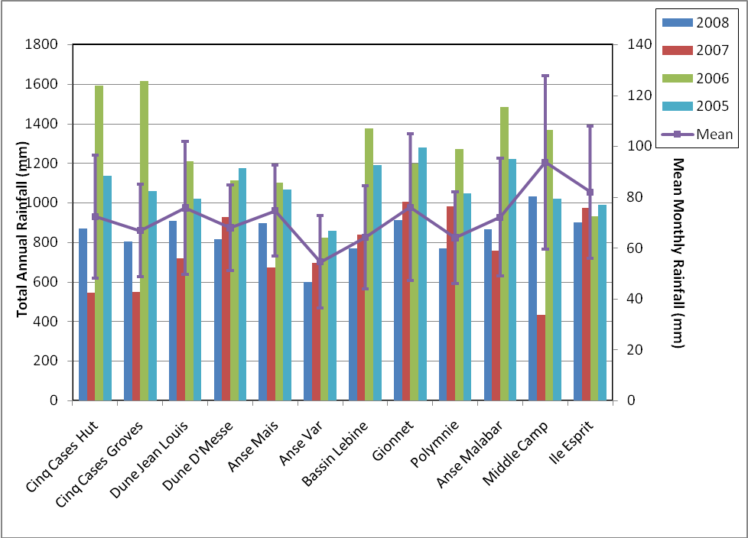

**Figure 3:** Total annual rainfall 2005 – 2008 and mean monthly rainfall for 2008 (error bars are standard error) for the rain gauge locations around the atoll.

# 3.0: Turtle Monitoring

Comprehensive analysis of the turtle monitoring data is not conducted here on Aldabra but is usually undertaken by Jeanne Mortimer. Jeanne is currently in the process of a detailed comprehensive analysis of the considerable amount of data collected on the turtles at Aldabra. This analysis will include the most up to date data from 2008 but detailed analysis has not been undertaken here and the results presented are a summary of the large amounts of data collected.

## 3.1: Track counts along external beaches (Green turtles)

A total of 353 counts were performed along Settlement beach in 2008, producing what is to date the most complete set of daily track counts for any year since the commencement of turtle monitoring. On each of these occasions the number of emergences was recorded with tracks being placed into one of three categories, very fresh (VF), half moon (HM) and emergence stopped by obstacle (ESBO).

Other beaches around the atoll are also checked for emergences and tracks counted on a regular basis. In each of the location groups (West Grande Terre, Cinq Cases, Dune Jean-Louis, Dune D’Messe, Northern Beaches and Anse Var) turtle track counts were conducted at least monthly. The only exceptions to this being the Cinq Cases region where there was no track count conducted for February, March and December.

Settlement Beach is divided into four zones where emergences are recorded. Zone 4 recorded the largest number of emergences in 2008 in all three categories of track recorded; 1567, 98 and 357 very fresh, half moon and emergence stopped by obstacle respectively (Table 2). While this zone is by far the most visited zone of the beach with a total of 2022 emergences throughout the year, it is also the zone with the largest number of emergences that were stopped by obstacles, 357, with 17.6% of emergences being prevented by obstacles. While Zone 1 recorded the lowest number of emergences (137) only 0.2% of these were prevented by obstacles.

Table 2: Turtle tracks observed on Settlement Beach, Picard

|  |  |  |  |  |  |  |  |  |  |  |  |  |  |  |
| --- | --- | --- | --- | --- | --- | --- | --- | --- | --- | --- | --- | --- | --- | --- |
|  |  | **Jan** | **Feb** | **Mar** | **Apr** | **May** | **June** | **July** | **Aug** | **Sept** | **Oct** | **Nov** | **Dec** | **Total** |
| Zone 1 | VF | 3 | 15 | 8 | 6 | 13 | 22 | 17 | 10 | 3 | 4 | 6 | 16 | 123 |
|  | HM | 0 | 1 | 1 | 1 | 2 | 1 | 2 | 1 | 1 | 0 | 0 | 1 | 11 |
|  | ESBO | 0 | 0 | 0 | 0 | 0 | 1 | 1 | 0 | 0 | 0 | 0 | 1 | 3 |
| Zone 2 | VF | 41 | 49 | 44 | 96 | 96 | 133 | 110 | 122 | 79 | 18 | 26 | 39 | 853 |
|  | HM | 1 | 3 | 2 | 7 | 1 | 4 | 8 | 1 | 3 | 1 | 3 | 3 | 37 |
|  | ESBO | 1 | 3 | 0 | 1 | 2 | 0 | 0 | 0 | 0 | 1 | 0 | 4 | 12 |
| Zone 3 | VF | 44 | 58 | 98 | 110 | 139 | 134 | 128 | 120 | 70 | 49 | 17 | 37 | 1004 |
|  | HM | 2 | 6 | 5 | 10 | 7 | 8 | 12 | 4 | 0 | 2 | 5 | 4 | 65 |
|  | ESBO | 5 | 4 | 7 | 11 | 5 | 5 | 3 | 5 | 3 | 0 | 4 | 7 | 59 |
| Zone 4 | VF | 71 | 117 | 214 | 244 | 233 | 207 | 153 | 102 | 96 | 77 | 22 | 31 | 1567 |
|  | HM | 1 | 7 | 15 | 14 | 10 | 12 | 11 | 12 | 3 | 6 | 2 | 5 | 98 |
|  | ESBO | 9 | 16 | 28 | 51 | 47 | 54 | 45 | 38 | 29 | 20 | 13 | 7 | 357 |
|  |  |  |  |  |  |  |  |  |  |  |  |  |  |  |
| **Total** |  | **178** | **279** | **422** | **551** | **555** | **581** | **490** | **415** | **287** | **178** | **98** | **155** |  |

Very fresh tracks are those recorded to have involved some level of digging in attempts to lay eggs. While there is no differentiation in the emergences that have successfully laid a clutch of eggs and those that have involved digging of a body pit with no eggs being laid. Figure 4 shows the average number of very fresh emergences recorded in each zone of settlement beach for each month of 2008. Emergence data for Settlement Beach in previous years has shown that the seasonality related to nesting activity of green turtles is dynamic with the peak in nesting activity varying slightly from year to year. In 2007 this peak in activity was in March which was followed by an incremental decline until September and December with the lowest average number of emergences. In 2006 the peak in emergence activity was in May. In 2008 the peak in emergence activity in Zone 4 was in April (Figure 4) although as is evident from the large standard deviations the number of very fresh tracks recorded varied quite considerably and there is very little difference between the average number of emergences recorded from March through to June. Error bars were not placed on the average emergences for the other zones as the large size of the standard deviations and the format of the graph would have made it difficult to read the mean values for each zone in each month.

As can be seen in Figure 4 it is the number of emergences in Zone 4 which drives the position of the peak emergence time as there is no identifiable peak in nesting activity in the other three zones along settlement beach. In fact when all very fresh emergences are combined for the four zones on settlement beach in 2008 June has the highest average number of emergences (Table 3).

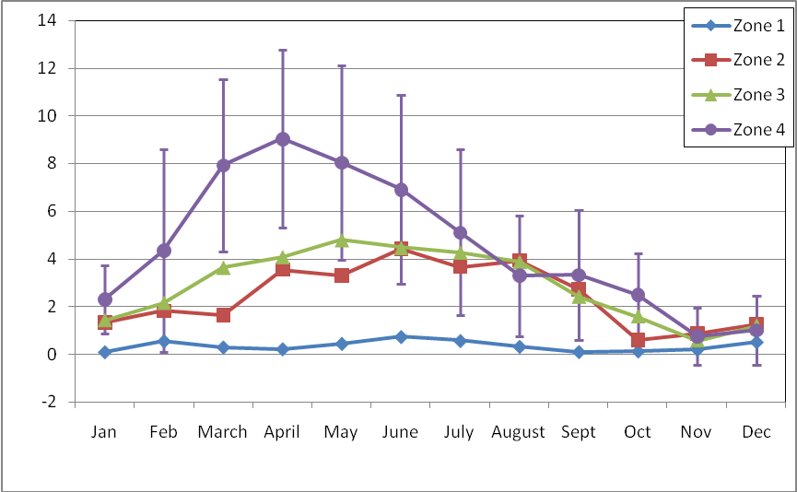

**Figure 4:** Average monthly number of very fresh (VF) emergence tracks recorded in each beach Zone on settlement beach in 2008 (error bars are standard deviation).

The number of emergences recorded at other beaches around the atoll show a similar pattern to that seen on Settlement Beach (Table 3). Peaks in nesting activity were observed during the same months with an obvious peak in May and June. It should be noted that the very high averages for some areas, in particular West Grande Terre and Dune Jean-Louis is an artefact of the number of beaches surveyed and the number of times each area was monitored throughout the month. For example West Grande Terre includes track counts for 22 beaches and while each is relatively short compared to Settlement beach the total number of tracks recorded often exceeds that detected on Settlement beach for the same day. In addition to this while Settlement Beach is surveyed each day and so the average is calculated for each day of the month the other beaches may have only been monitored once or twice each month. As a result the average emergences for the other beaches are monthly averages determined by the number of monitoring events while effectively that for Settlement Beach becomes a daily average.

Table 3: Mean monthly number of turtle tracks observed for all beaches around the Atoll

|  |  |  |  |  |  |  |  |  |  |  |  |  |
| --- | --- | --- | --- | --- | --- | --- | --- | --- | --- | --- | --- | --- |
|  | **Jan** | **Feb** | **Mar** | **Apr** | **May** | **June** | **July** | **Aug** | **Sept** | **Oct** | **Nov** | **Dec** |
| Settlement | 5.1 | 8.2 | 11.7 | 15.2 | 15.5 | 16.5 | 13.2 | 11.4 | 8.3 | 4.8 | 2.4 | 4.0 |
| West Grande Terre1 | 18.0 | 35.8 | 43.5 | 56.0 | 71.3 | 92.0 | 71.3 | 44.0 | 43.0 | 15.0 | 11.0 | 23.0 |
| Dune D’Messe2 | 3 | 1.5 | 6 | 3 | 1 | 4 | 0 | 0 | 0 | 1 | 2 | 0 |
| Dune J-L3 | 5 | 11 | 21 | 19 | 24 | 30 | 17 | 17 | 6 | 4 | 6 | 3 |
| Cinq Cases4 | 0 |  |  | 1 | 1 | 0 | 0 | 0 | 0 | 0 | 0 |  |
| North5 | 6.5 | 2.5 | 15 | 17 | 21 | 22 | 10 | 17 | 12 | 3 | 1 | 1 |
| Anse Var6 | 0.5 | 0 | 0 | 0 | 1 | 0 | 0 | 1.5 | 0 | 0 | 0 | 0 |

1 Beaches included in count – 2,3,4,5,6,7,8,9,10,11,12,13,14,15,15.5,16,17,17.5,18,19,20,21. FF tracks not recorded.

2 Beaches included in count – 23, 24, 25, 26, 27, 28.

3 Beaches included in count – 29, 30, 31, 32, 33, 34, 35, 36. FF only recorded on 29, 30, 31.

4 Beaches included in count – 37, 38, 38.5, 39. FF not recorded.

5 Beaches included in count – 40, 41, 42, 43, 43.5, 44, 45, 46, 51, 55. FF only recorded on 40, 41, 42, 43. Anse Var included

6 Beaches included in count – 55 only. Anse Var counted in North beach counts as well as in its own count.

## 3.2: Track counts along lagoon beaches (Hawksbill turtles)

Hawksbill turtles on Aldabra nest only on the inner lagoon beaches. Breeding activity is primarily restricted to the period between September and March and during this time attempts are made to check these beaches once a month.

Track counts on the inner lagoon beaches for hawksbill emergences were conducted on only three occasions in 2008. Problems with boats, high staff turnover and the absence of a Research Officer for much of the appropriate time for these counts meant that they were restricted to three occasions early in the year, 1 in January and 2 in February. On all three of these counts the majority of beaches could not be properly included as there was not sufficient sand or beach for emergence of nesting adults. On the one occasion in January one very fresh track was detected on beach 48a and one fairly fresh track also on this beach, while on the second count in February only fairly fresh tracks were detected with one on beach 48a and another on 50a.

## 3.3: Tagging of Nesting Turtles

Tagging of nesting turtles was carried out on a number of beaches around the atoll during specific tagging activities on Settlement Beach or opportunistically during other monitoring at other beaches around the atoll. A total of 378 individual turtles were recorded during these activities. This included 219 individuals that were newly tagged in 2008 with the remaining 159 already having at least one tag present. The nature of this data base and activity means that turtles that were encountered at other times but had no tag applied or did not already have a tag are not recorded so no information on the percentage of individuals encountered during nesting activities that are not tagged or have no tags is unavailable.

Tagging of nesting turtles allows some information on the number of times females return within a season. As patrols for nesting turtles are not carried out every night any data on the number of returns is at best a minimum number of emergences. In 2008 of the turtles detected with tags (returning turtles) 42 had been tagged for the first time in 2008. One of these individuals was detected a total of 5 times, including the initial tagging event. Four others were first tagged in 2008 and returned another 4 times. Seventeen of the turtles individually identified were tagged during previous years and were identified in 2008.

## 3.4: Tagging of juvenile turtles

Juvenile turtles are tagged on Aldabra during turtle “rodeo” activities in the lagoon. In 2008 these were conducted at least once every month with the only exceptions being March and November when no rodeos were held. When juvenile turtles are caught they are weighed, measured and tagged if they have not already been tagged. A total of 104 juvenile turtles were caught in 2008 with 66 of these being green turtles and the remaining 38 hawksbills. Six percent of the green turtles caught were recaptures and 47% of the hawksbills were also recaptures.

# 4.0: Aldabra Tortoise Monitoring Programme

Data on the giant tortoises on Aldabra has been collected since 1998. This information includes the number, sex and size of individual tortoises recorded along 12 transects around the atoll (Figure 1). This information is collected, when possible, on a monthly basis providing valuable information on the population size, structure and distribution of this species around the atoll. It also allows for annual and monthly variations in these parameters to be investigated.

There are currently two models used to look at the population of tortoises on the atoll; Bourns’ and Rainer’s. Both of these require updates to the files and links used for the final calculations before results can be presented. This will be worked on for the 2009 annual report and is commented on in the RO comments for this report. Results presented below are summary results from the four main areas of the atoll where transects are located; Picard (3 transects), Cinq Cases (3 transects), Malabar (3 transects) and Grande Terre (3 transects).

**Picard**

Tortoise monitoring was conducted on Picard for all three transects once each month. Anse Var consistently records the lowest number of tortoises along the transect and individuals in this part of Picard are on average smaller than those detected on the other two transects, Coastal and Back Path (Figure 5). While the coastal transect often records a higher number of individuals it should be noted that the width of this transect is 20 m (10 m on each side of the transect) while for all other tortoise monitoring transects on Aldabra the width is 10 m (5 m on each side of the transect). This will not only influence the number of individuals recorded but also the mean size as the increased sample size will influence the calculation of the mean and any variation around this.

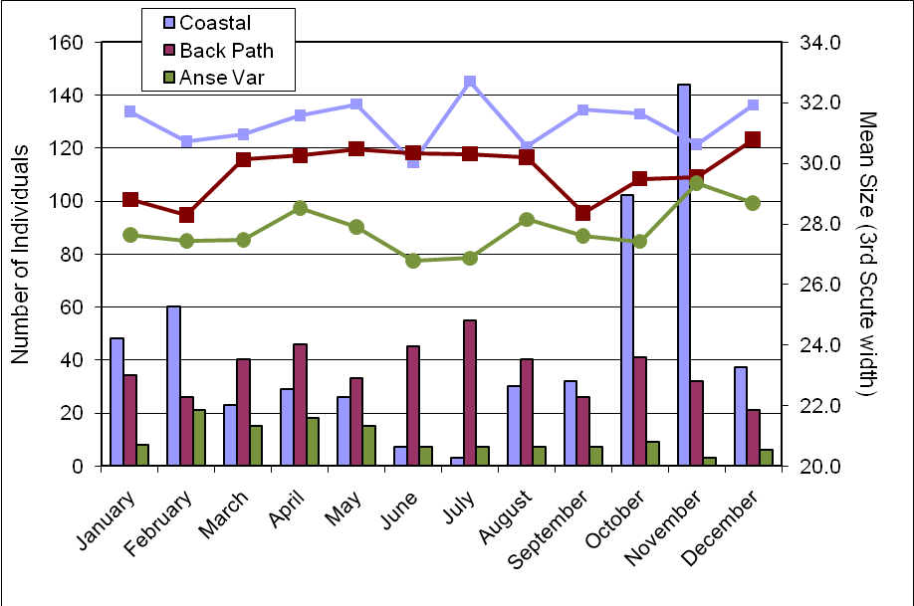

**Figure 5:** Number of individuals (columns) and mean size (line) as determined by the width of the third scute for the three giant tortoise transects monitored at Picard.

**Malabar**

Tortoise monitoring was completed at the three transects on Malabar each month of 2008. The coastal transect at Middle Camp consistently records the lowest number of individuals of all three transects while the transect at Malabar camp records the highest number of individuals and individuals with the highest mean size (Figure 6). Despite the Malabar transect recoding the highest number of animals, these numbers were mostly below the numbers recorded on Picard and the mean size was also smaller than those recorded on any of the three transects on Picard.

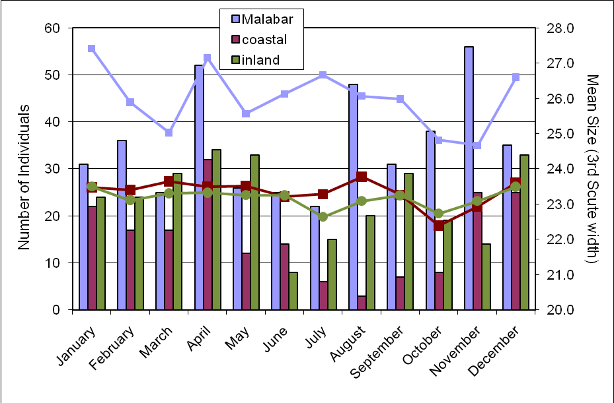

**Figure 6:** Number of individuals (columns) and mean size (line) as determined by the width of the third scute for the three giant tortoise transects monitored on Malabar.

**Grand Terre – Cinq Cases, Dune Jean-Louis, Dune D’Messe**

Historically monitoring of the giant tortoise population on Aldabra has shown that the area around Cinq Cases on Grande Terre has the highest number of individuals and these tend to be of a smaller size than in many of the other areas of the atoll. The data collected on all transects on Grande Terre during 2008 showed the same trends with the transect at Cinq Cases Coco and Dune D’Messe Coastal consistently recording the largest number of individuals (Figure 7 and Figure 8). All 6 transects on Grande Terre recorded individuals of a much smaller size than those recorded on the transects on Picard and also Malabar. Individuals on the Cinq Cases Groves transect tended to be the smallest of any transect with many of these individuals falling under the size threshold used for determining the sex of individuals. In some locations this threshold perhaps needs reviewing and reconsidering and sexing of individuals in these locations where most animals are under the 20cm threshold should also be attempted and recorded where possible to obtain estimates of the sex ratios of the local populations in these areas.

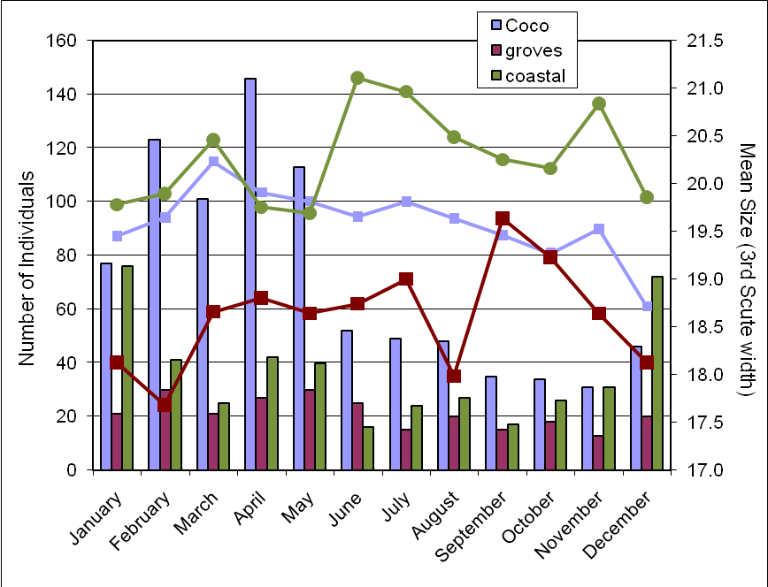

**Figure 7:** Number of individuals (columns) and mean size (line) as determined by the width of the third scute for the three giant tortoise transects monitored on Grande Terre, Cinq Cases.

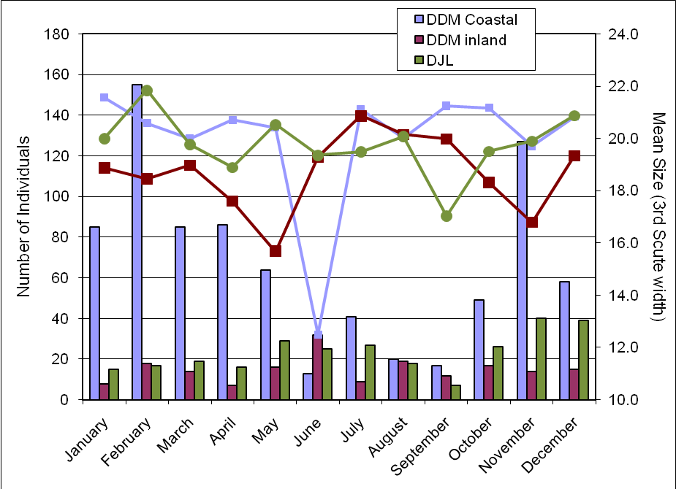

**Figure 8:** Number of individuals (columns) and mean size (line) as determined by the width of the third scute for the three giant tortoise transects monitored on Grande Terre, Dune Jean Louis and Dune D’Messe.

**Population models**

In 2004 Rainer von Brandis developed one of the population models available at the station to estimate the population size of the giant tortoise on Aldabra. This model is based on the trends in the tortoise numbers along the different transects (see RO Annual Report 2004 and 2005 for further information). As part of this model the Threshold for Potential Concern (TPC) was estimated. This threshold is primarily based on the trends in overall numbers of tortoises detected along the transects and factors in 1) the number of successive annual declines in tortoise numbers, 2) the percentage of variation in tortoise numbers between years and 3) the correlation coefficient of tortoise numbers over time. The level of concern in regards to the population trends in tortoises is then rated on a scale of one to three with one being no real concern and three being action is required. In 2008 analysis of the tortoise transect data in this model triggered a Level 1 concern (no action required) for 6 of the transects while the remaining 6 had no level assigned to them. The 6 that resulted in a Level 1 concern were Picard Coastal, Picard Back Path, Malabar, Dune D’Messe coastal, Dune D’Messe inland and Dune Jean-Louis.

Unfortunately the Aldabran giant tortoise Monitoring Database designed by David Bourn in 2004 is not currently running in a way as to allow up to date population estimates from the data collected and entered. All monitoring data for the giant tortoises are currently entered into this data base as well as into the one developed by Ranier. However, the links in the access data base are mostly out of date and broken and as such this data base can not currently be used to generate population estimates.

# 5.0: Bird Monitoring

There are a number of different monitoring activities undertake on Aldabra to monitor the bird populations. This includes monitoring focussing on land birds, waders and a number of the sea bird species on the atoll.

## 5.1: Land birds

The land bird monitoring involves seven of the tortoise transects located around the atoll (Figure 1). Along each of these transects point counts are conducted (counts of birds seen or heard over 4 minutes within a 25m radius of a specific point along the transect). The number of points monitored ranges from 4 – 9 depending on the location of the transect. The monitoring of land bird abundance around the atoll at these seven transects has been undertaken since 2002 and continues to provide valuable information, particularly in regards to the abundance of passerines. Point counts were conducted on all seven transects every month during 2008.

The total number of birds recorded across all point counts on all transects is shown in Figure 9. Displayed on a logarithmic scale it clearly shows that the most abundant species was the Souimanga sunbird with the Malagasy turtle-dove the second most abundant species recorded. It is important to note that this figure does not account for differences in abundance between transects but shows the total number of individuals recorded. Despite this the sunbird was indeed the most abundant species across all transect locations. While the Malagasy nightjar was not recorded on any of the transects, most likely due to the methods used and the low detection probability of this species during diurnal surveys.

Figure 10 shows the mean annual total number of birds recorded on the land bird transects from 2002 to 2007. It also shows the total number recorded for each species in 2008 on the same transects. The numbers recorded for 2008 are extremely similar to the average total number recorded for the previous 5 years and indicate no significant decrease or increase in the number of birds detected throughout the year. It does show a slight decrease in the number of pied crows detected at the point counts along the transects although their highly mobile nature could easily influence this along with the methods designed more specifically for passerines. The total numbers recorded for 2008 fall well within the variation in numbers for the previous 5 years. Standard errors were calculated for these totals but are not shown on the graph due to the logarithmic scale used to plot the number of birds recorded.

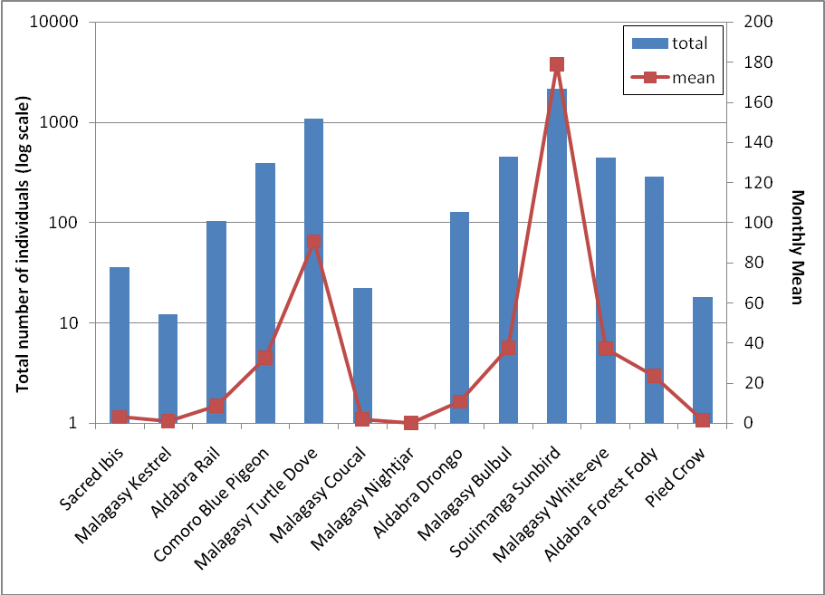

**Figure 9:** Total number and monthly mean number of birds recorded across all point counts on all transects for 2008.

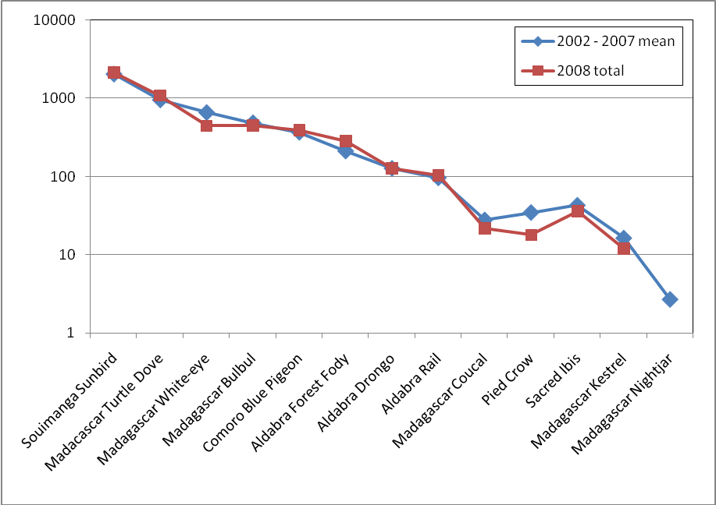

**Figure 10:** Mean annual total number of birds recorded on the land bird transects during 2002 – 2007 and total number of land birds recorded for each species in 2008 on the same transects.

As shown in Figure 10 the total number of individuals recorded for all point counts on all monitoring transects for 2008 did not differ greatly from the average number of individuals for the years 2002 – 2007. In fact the total number of individuals recorded during land bird monitoring since 2002 shows very little annual variation for most species (Figure 11). The number of Aldabran rails, Madagascan coucals and pied crows show some variation from year to year. A more detailed analysis of the data and trends in numbers is required to show any significant increases or decreases in abundance as well as distribution of the 14 species recorded on the land bird transects. It should also be noted that the methods used during this monitoring may not be the most appropriate for a number of the species included in the counts – specifically the nightjar, kestrel, crow and rail. The point count method is most often used and most appropriate for abundance estimates of passerines and this should be considered in any further analysis of this data and in any interpretation of the data collected thus far.

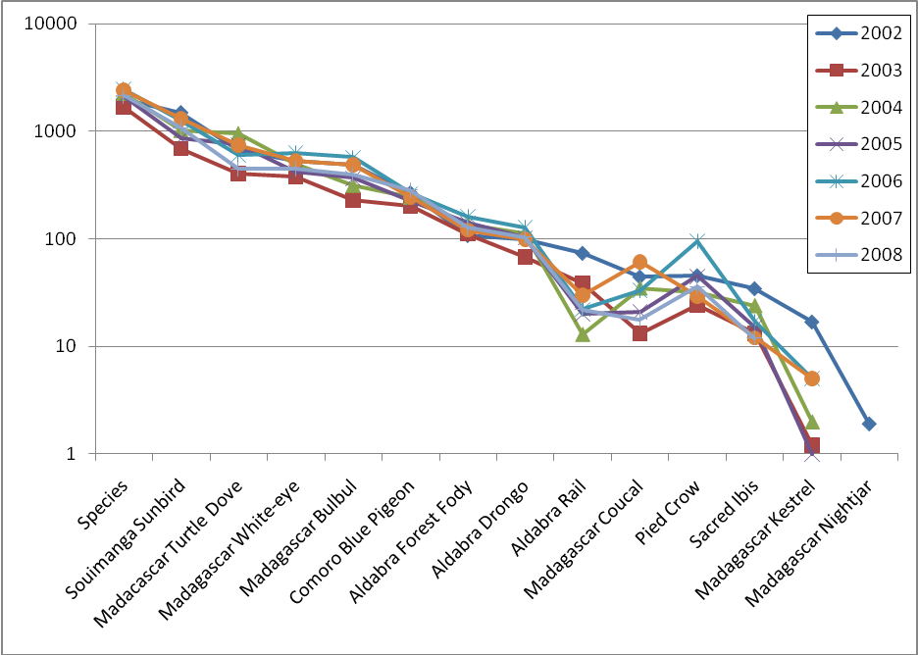

**Figure 11:** Total number of land birds recorded for each species on all the land bird monitoring transects for the years 2002-2007 (totals are annual total number of individuals for all point counts on all transects).

Rail Monitoring

Monitoring of the rail populations on the individual islands of Aldabra is not currently undertaken. Previously this monitoring of the rail was conducted at a number of transects with the use of call play back tapes.

As with the previous annual report, the current monitoring of the rail population on Picard is restricted to sightings and counts of individuals recorded during the monthly land bird monitoring. The data gathered on the land bird point counts at the transect on Picard show very little variation in the total number of birds recorded throughout the year. While the numbers for 2008 are higher than the previous year they are slightly lower than others for example 2006 and 2004 (Table 4).

Table 4: Yearly total for Aldabran rails recorded on land bird transects.

|  |  |  |  |  |  |  |  |
| --- | --- | --- | --- | --- | --- | --- | --- |
|  | **2002** | **2003** | **2004** | **2005** | **2006** | **2007** | **2008** |
| TOTAL | 74 | 67 | 112 | 103 | 127 | 98 | 104 |

Monthly totals for 2008 and 2007 (Table 5) show similar trends in the number of birds detected. These numbers are not presented for other preceding years as the data files for the land bird counts in previous years require significant editing to allow accurate calculation of values. This is particularly the case for calculation of monthly totals and averages. In point count methods such as these records of 0 birds in a particular species for a particular point along any one of the transects are important data points. These values have previously been excluded from the summaries and calculations of mean sightings and need to be included for an accurate representation of species distribution and abundance. Attempts will be made to rectify this for the next annual report as well as coming monthly reports.

Any trends evident in the monthly numbers and abundance may indicate post breeding increases in the population. These could then be used in conjunction with previous surveys to provide an indication of the most appropriate timing for targeted surveys of the rail populations, as suggested in the previous annual report and following the methods of Huxley.

Table 5: Total number of rails recorded on land bird transects each month.

|  |  |  |  |  |  |  |  |  |  |  |  |  |
| --- | --- | --- | --- | --- | --- | --- | --- | --- | --- | --- | --- | --- |
| **TOTAL** | **Jan** | **Feb** | **Mar** | **Apr** | **May** | **June** | **July** | **Aug** | **Sept** | **Oct** | **Nov** | **Dec** |
| 2008 | 7 | 8 | 8 | 10 | 11 | 9 | 15 | 13 | 7 | 5 | 4 | 7 |
| 2007 | 11 | 13 | 10 | 20 | 11 | 3 | 3 | 8 | 4 | 1 | 9 | 5 |

## 5.2: Wader counts

Counts of the wading birds along Settlement Beach are made at least twice a month on Aldabra as well as being recorded on the walk from Dune Jean-Louis and Dune D’Messe and at Dune Patates when possible. The large number of factors that influence the abundance of waders makes analysis of trends and changes in numbers difficult and increases the number of independent counts required. Height and time of tide, temperature and other weather variables as well as season and time of year are all likely to have a significant impact on the number of birds recorded. Given the size of the atoll and the high mobility of the species monitored the influence of these factors in other areas of the atoll is also likely to impact the numbers recorded at other monitored sites. These factors and their influence on abundance trends makes it difficult to record the data collected throughout the year. Figure 12 shows the species composition and relative abundance of species recorded on Settlement Beach throughout the year. Dimorphic egrets and crab plovers made up the majority of the individuals recorded along Settlement Beach; 35 and 27 % respectively. Both of these species as well as ruddy turnstones were recorded on every monitoring event and the mean number recorded throughout the year is shown in Figure 13.

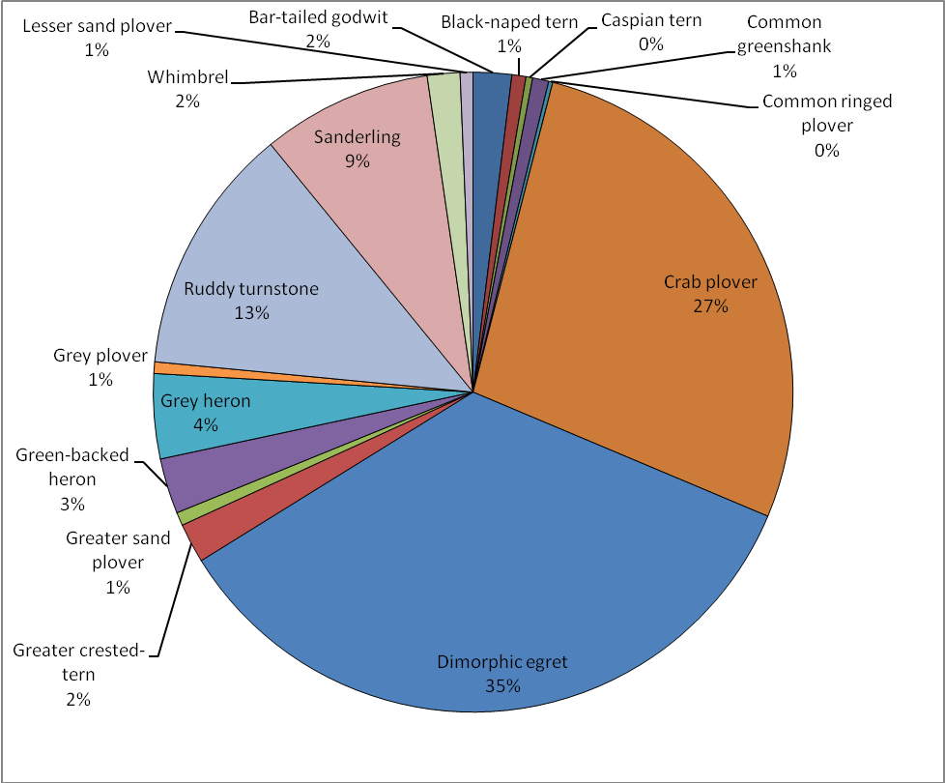

**Figure 12:** Species composition and relative abundance of migratory waders along Settlement Beach.

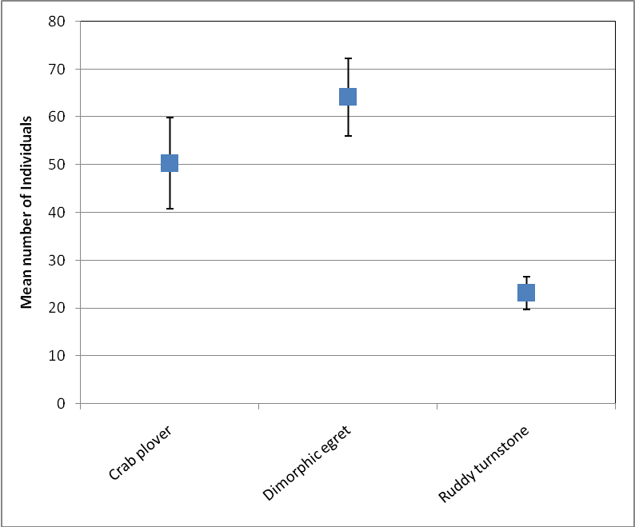

**Figure 13:** Mean number of individuals of the three most abundant species recorded along Settlement beach (error bars are standard error).

A number of species identified during wader counts along Settlement beach were recorded on fewer than 6 of the monitoring events, representing less than 20% of the monitoring occasions. The majority of these species were only recorded on one occasion and this includes sightings of a Pacific golden-plover, a Terek sandpiper and a brown noddy. Other species that were only recorded as being sighted once were recorded in much higher numbers, including little terns, Saunders’ terns and lesser crested terns. Some inconsistencies are apparent in the data with little terns only recorded on one occasion with a total of 51 individuals noted. These birds are generally seen in the air and may be present on many occasions but not recorded by some staff as they are not considered to be waders.

Table 6: Wader species identified on fewer than 6 monitoring occasions and number of individuals seen off Settlement Beach.

|  |  |  |
| --- | --- | --- |
|  | **Total Number of Individuals** | **Number of Occasions recorded** |
| Common sandpiper | 13 | 2 |
| Curlew sandpiper | 13 | 2 |
| Eurasian curlew | 3 | 2 |
| Little tern | 51 | 1 |
| Saunders' tern | 14 | 1 |
| Lesser crested tern | 5 | 1 |
| Little stint | 3 | 1 |
| Brown noddy | 1 | 1 |
| Pacific golden-plover | 1 | 1 |
| Terek sandpiper | 1 | 1 |

Monitoring of wader species and abundance is also undertaken on the walk from Dune Jean-Louis and Dune D’Messe during the course of usual monthly monitoring activities. This walk passes Dune Patate which is an important roosting site for sand plovers and curlew sandpipers along with other species. Current recording methods fail to specify the location of waders identified during the walk between Dune Jean-Louis and Dune D’Messe and in such instances abundance of individuals at Dune Patate is included in the overall total of waders seen between the two locations. Additional counts of species and abundance for Dune Patate are recorded when the walk between the other two monitoring camps is not undertaken. Unfortunately this means there is no regular record of the species and number of individuals for the area encompassing Dune Patate. This complicates the analysis of this data and limits its use in identifying seasonal trends in numbers or species presence. Future wader counts conducted along this stretch of Grande Terre will specifically identify the species and number of individuals recorded at Dune Patate.

A number of species not recorded along Settlement beach were recorded along this stretch of coast including brown noddies and Oriental pratincole (Table 7). Similar to results obtained along Settlement Beach the most abundant species included crab plovers and ruddy turnstones (Figure 14).

Table 7: Wader species identified on only 1 occasion and number of individuals seen from Dune Jean-Louis to Dune D’Messe.

|  |  |
| --- | --- |
| **Species** | **Total Number of Individuals** |
| Black-naped tern | 1 |
| Oriental pratincole | 1 |
| Common greenshank | 2 |
| Terek sandpiper | 2 |
| Brown noddy | 5 |

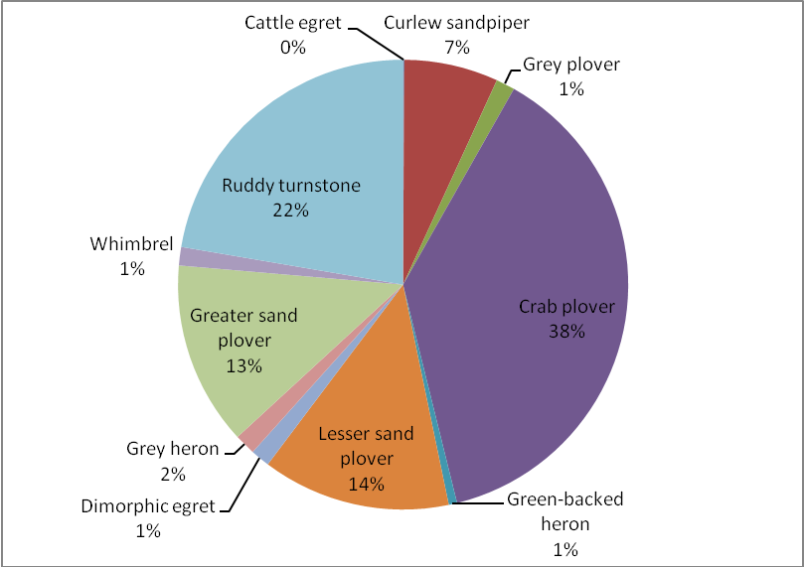

**Figure 14:** Species composition and relative abundance of migratory waders along the South coast of Grande Terre from Dune Jean-Louis to Dune D’Messe (including Dune Patate).

Crab plover

During 2007 two complete atoll counts of the crab plovers were conducted, during two consecutive wintering seasons, March and December. The data collected in 2007 suggested that the population wintering at Aldabra was 3000-3800 individuals. No record can be found of similar atoll wide counts being conducted in 2008. There was no count conducted in December but it remains unclear if the count was completed in March.

Analysis of the crab plover count data on Settlement Beach from 2007 indicated that the number of crab plovers observed and recorded along Settlement Beach may be useful as an index of population size and status on the atoll. The relationship observed between the sea level height at high tide and the number of individuals recorded was highly significant with a positive relationship between the height of high tide and the number of individuals. This relationship requires more data to confirm the details and to clarify the nature of the number of individuals recorded and the population size.

Currently the number of crab plovers is not included in the usual monitoring but is instead recorded during wader counts which are conducted on Settlement Beach twice monthly and within 2 hours of low tide. This is not the optimal time for a realistic record of the numbers of crab plovers as the 2007 data indicates they are only present in relatively high numbers at tide heights during the survey of over 3.4m.

Data collected in 2008 does not clearly support this relationship (Figure 15) with high numbers of crab plovers recorded along Settlement beach during some months but not necessarily in correlation with the highest tides of that month. However, this is highly dependent on the time of the count and in most cases counts were only conducted at low tide.

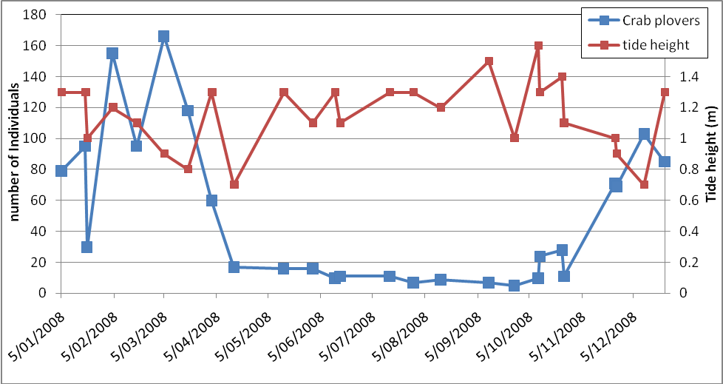

**Figure 15:** Abundance of crab plovers along Settlement Beach as recorded during migratory wader monitoring in 2008 and tide height at time of monitoring.

Closer inspection of the relationship between tide height and number of crab plovers recorded during the monthly wader monitoring shows no clear relationship between the two (R2 = 0.13). Despite being significant (p=0.06) very little of the variation observed in the numbers can be explained by the variation in tide height (13%) and this cannot really be considered as biologically meaningful. This is more likely to be due to a lack of counts being conducted at sufficiently high tides as this is more likely to influence the number of crab plovers recorded, than a lack of influence of tide height on numbers.

Monthly counts of crab plovers in other areas of the atoll were only conducted in January and March and not other data is available in terms of abundance in other locations (Table 8).

Table 8: Monthly counts of crab plovers.

|  |  |  |  |  |
| --- | --- | --- | --- | --- |
|  | **Number** | **Date** | **Number** | **Date** |
| La Gigi | 128 | 11-Jan | 95 | 8-Mar |
| Ile Moustiques | 870 | 11-Jan | 950 | 8-Mar |
| Grand Cavalier | 7 | 11-Jan |  |  |
| Petit Cavalier | 0 | 11-Jan |  |  |
| Settlement Beach | 250 | 11-Jan |  |  |
| Ilots west of Ile Michel | 310 | 26-Jan |  |  |
| Dune Jean-Louis-D'Messe | 347 | 11-Jan | 410 | 8-Mar |

Daily counts of the number of crab plovers along Settlement Beach appear to have been instigated in early 2008. Counts could be found for each day in January, 22 days in February, 8 days in March and 5 in April. It is not clear if days in these later months with no count recorded were days on which the count was conducted but no crab plovers recorded or days on which no count was completed. Counts recorded in January ranged from 4 to 908. The relationship between the number of individuals recorded and the height of tide most likely to be influencing the count are shown in Figure 16. As no information is available on the exact height of the tide at the time of the count the height the closest tide minimum or maximum likely to influence the count was used to investigate the relationship between the tide height and the number of birds recorded.

There is a clear positive relationship in the number of birds and tide heights above approximately 2.8m (Figure 16). There is also a positive relationship between the number of individuals and a decreasing tide height below 1.4m. This unexpected result with lower tides is most likely due to the exposure of suitable foraging habitats out on the reef top which are only exposed with particularly low tides. The high number of birds recorded with very high tides is likely to be a consequence of inundation in other areas inside the lagoon which the birds use for feeding and roosting.

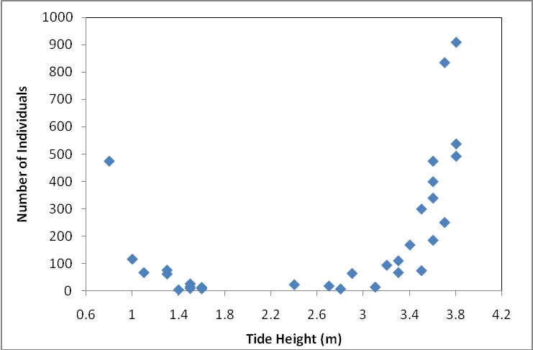

**Figure 16:** Abundance of crab plovers in relation to tide height along Settlement Beach during daily abundance counts in January 2008.

Flamingo

During 2007 a number of excursions and trips to the Takamaka flamingo nesting pool were undertaken and reported in the annual report. No record of similar excursions can be located at the station for 2008 and there are no data sheets or electronic records of other sightings of flamingos. A summary of sightings recorded in monthly reports is provided in Table 9.

The electronic data sheet for flamingo records contains one sighting noted on the 24th of February 2008 of 14 individuals at the landing stage tidal pool at Cinq Cases. Notes included in monthly reports from early 2008 detail some sightings of flamingos as part of a ranger’s personal project undertaken by Catherina Onezia. A summary of these are presented in Table 9. In the April monthly report provided by the RO there are some additional details on a visit to the Takamaka breeding pool during monthly monitoring activities and the GEP related activities. Unfortunately no date is provided and other important details are not stated. During this visit 8 young chicks, not more than a few weeks old, were recorded along with 6 adult birds. This record is only the third for unfledged chicks on Aldabra and the site is rarely visited. This site was also visited in April 2007 and chicks were recorded at this time.

Table 9: Details of sightings of flamingos.

|  |  |  |  |
| --- | --- | --- | --- |
| **Date** | **Location** | **Time** | **Number**  **Adults (juv)** |
| 23/1/2008 | Cinq Cases landing stage tidal pool | 8:30 am | 27 (8) |
| 25/1/2008 | Cinq Cases landing stage tidal pool | 9:00 am | 7 |
| 24/2/2008 | Cinq Cases landing stage tidal pool | 8:15 am | 14 |
| No date provided | Takamaka nesting pool | None given | 6 (8) |

## 5.3: Sea birds

Red-tailed tropicbird (Phaeton rubricauda) monitoring

2007 saw monitoring of the red tailed tropicbirds that breed on the islets inside the lagoon, adjacent to Picard provide valuable data on the breeding seasonality and nesting success for this species. Unfortunately this monitoring was not conducted every month during 2008, due to changes in staff and staffing levels on the atoll. The monitoring of red-tailed tropicbird nests on the islets was conducted 6 times between January and April. Monitoring for this species then stopped in mid-April and was not conducted again until October. However, when resumed it was not undertaken in any systematic way but rather as random observations on only one of the islets used by the red-tailed tropicbirds.

Results from the early months of 2008 indicate similar trends in breeding activity to those recorded in 2007. January saw an increase in the nesting activity on the islets with 16 out of the 21 nests being monitored at the time being active. February saw a similar percentage of known nests active with March showing a marked decrease in the number of active nests when compared to February. In April only two active nests were found marking the end of the breeding season for this species. Reports of red-tailed tropicbird monitoring from the individual monthly reports for 2008 are sketchy and limited at best and further checking of the raw data and analysis is required for a more detailed summary. In the April monthly report the drop in active nests was attributed to the end of the breeding season. This species is likely to breed all year round on Aldabra as reported from previous monitoring work with a peak in breeding activity from January thru to April. At the time it was recommended in the monthly report that monthly checks continue to be made of the islets until September when monitoring should be increased again to twice a month. These checks were not carried out due to staff constraints and no data is available on the nesting activity of this species from April onwards until October.

For the last three months of 2008 a single islet inside the lagoon and any active nests on it were checked twice a month, at low tide, to allow access to the islets by foot. The status of active nests on the islets was recorded. However, unfortunately on almost all the occasions nest were checked no numbered marker was placed on them and so the fate of individual nests cannot be followed and no indication of the number of breeding pairs can be obtained.

It is recommended that there is a review of the current monitoring methods for the red-tailed tropicbirds and Islets monitoring. It appears that the majority of nests fail at the egg stage due to high rates of predation. This could be due to crabs or rats. Despite the islets being believed to be rat free on at least one occasion a rat was seen, indicating that they may in fact not be rat free and this could be having a considerable impact on the nesting seabirds.

*Vagrant and unusual bird sightings*

As with the records of crab plover counts no organised or electronic version of records of vagrants or unusual bird sightings appears to have been maintained at the station. Details of bird records that I was able to find are included below (Table 10) and were mostly taken from the unusual sighting or interesting observation section of the monthly reports. Unfortunately many details are missing from these including date, time and location specifics.

Table 10: Details of sightings of vagrant and unusual bird species.

|  |  |  |  |
| --- | --- | --- | --- |
| **Species** | **Location** | **Number** | **Date** |
| Northern wheatear | Back path | 1 | 2/2/2008 & 12/2/2008 |
| Wire tailed swallow | Research block | 1 | 8/2/2008 |
| Saunders / Little tern | Settlement Beach | 14 | 18/2/2008 |
| Great white egret | Cinq Cases | 1 | Not provided |
| Yellow wagtail (*Motacilla flava*) | Settlement Beach | 1 | 24/9/2008 |
| Tree pipits (*Anthus cervinus)* | Old Settlement | 2 | 26th of October |
| Broadbilled roller (*Eurystomius glaucurus)* | Settlement Beach | 1 | 8th of November |

# 6.0: Butterflyfish Monitoring

Monitoring of the species diversity and abundance of species of Chaetodonitds along a transect previously established by the Aldabra Marine Programme (AMP) was conducted during 2008. Unfortunately this monitoring was not conduted every month and the transect often went for many months without any monitoring being undertaken. Up until November there was no data sheet used during this monitoring, instead counts were recorded on underwater slates and entered directly into the excel database. Electronic records could only be located for January, April, November and December and it appears these were the only months during which this monitoring was completed.

In July a new Research Officer arrived on the atoll and attempts were made to locate the transect line after the marker buoy had been lost, however, no monitoring was conducted. In August the transect line was replaced and September the fish identification sheet was updated with colour photographs. However, no monitoring took place in either month or in October. In November with the arrival of another new RO monitoring re-commenced, the methods used were updated and important safety protocols for diving implemented. The new protocols introduced in regards to the Butterfly Fish transect included Rangers now being required to complete and pass a fish identification test. New in water data sheets have been created to make recording of species easier and they include basic line drawings of each species.

There appears to have been considerable confusion in regards to the methods used previously and those recommended by AMP to conduct this transect and hopefully this has now been clarified. Further clarification will be done and protocols developed for this transect which will hopefully improve the quality and usefulness of the data. One of the immediate issues with the monitoring addressed in November was the dive protocol which was being used. At some point the methods had been changed from 3 dives throughout the day, to encompass any diurnal variation in the species and number of individuals, to 3 dives one after the other, effectively leading to a dangerous dive profile.

Given the previous confusion with methods for this monitoring no analysis can be made on the 2008 data without considerable transformation of the data available. Also the limited number of monitoring events throughout the year makes it difficult to detect and trends in the species diversity and abundance. Table 11 below provides a summary of the data collected during 2008, showing the abundance of all species recorded along the transect for each monitoring event. In the instances when more than one count was conducted on any given day the average number of fish recorded for that day is shown, i.e. January, November and December. In April 2 dives were conducted on consecutive days.

Table 11: Species and abundance of butterfly fish recorded on the monitoring transect.

|  |  |  |  |  |  |
| --- | --- | --- | --- | --- | --- |
|  | **January** | **April** | **April** | **Nov** | **Dec** |
| *Chaetodon auriga* | 3.3 | 2.0 | 5.0 | 1.7 | 2.3 |
| *Chaetodon bennetti* | 0.3 |  |  |  |  |
| *Chaetodon falcula* |  |  | 1.0 | 1.0 | 1.0 |
| *Chaetodon guttatissimus* | 7.7 | 3.0 | 4.0 | 2.3 | 1.7 |
| *Chaetodon kleinii* |  |  |  |  | 1.3 |
| *Chaetodon lineolatus* |  |  |  | 1.0 |  |
| *Chaetodon lunula* | 6.3 |  |  | 3.7 | 9.0 |
| *Chaetodon melannotus* | 2.3 |  |  | 3.0 | 3.0 |
| *Chaetodon meyeri* | 2.3 |  |  | 0.7 | 1.3 |
| *Chaetodon trifascialis* |  |  |  | 2.3 | 1.0 |
| *Chaetodon trifasciatus* | 2.0 | 4.0 | 4.0 |  | 1.3 |
| *Chaetodon unimaculatus* |  |  |  | 0.3 |  |
| *Chaetodon xanthocephalus* | 0.7 | 2.0 |  |  | 1.0 |
| *Forcipiger flavissimus* | 7.0 |  | 4.0 | 2.5 | 4.3 |
| *Hemitaurichthys zoster* | 0.3 |  |  | 2.0 | 3.0 |
| *Heniochus acuminatus* |  | 3.0 |  |  |  |
| *Heniochus diphreutes* |  |  |  | 4.3 | 1.0 |
| *Heniochus monoceros* |  |  |  | 1.3 | 0.7 |

# 7.0: Subsistence Fishing

Aldabra Station staff members regularly go fishing to provide subsistence fish for consumption of residents. Detailed information on the catches during these trips is recorded including the amount of time spent fishing (bottom and trawling), number of lines deployed, location and details of fish caught (species, weight, length). This information can then be used to calculate an index of the catch per unit effort which serves as an index of fish abundance.

While CPUE (catch per unit effort) can be used as an indication of changes in abundance the linear relationship between the measure of effort and catch can break down for numerous reasons. Changes in staff and the diligence in recording parameters such as number of lines and time spent fishing is one reason CPUE can be difficult to present. Over the last 12 months on Aldabra 3 changes in Research Officer with little or no overlap between them and extended periods of time with no Research Officer have meant that the subsistence fishing data for 2008 will require significant time to check and rectify inconsistencies. For example, a new format of the data sheet which works particularly well in some respects fails to make a clear definition between the number of staff present on the boat and the number of lines deployed. This has a considerable impact on the calculation of CPUE.

Summary data for the subsistence fishery on Aldabra for 2008 is presented in Table 12. It shows that similar to past years bottom fishing caught species made up the majority of the total catch. This is more likely related to amount of time spent bottom fishing compared to trawling rather than a difference in the relative measures of CPUE. Unsurprisingly despite bottom fish contributing almost 5 times as many fish in terms of absolute numbers the total weight of bottom fish caught was less than double that of trawl fish (Table 12). As in previous years those species that made up the majority of the catch were, in order of importance, *Variola louti, Lutjanus bohar, Caranx ignobilis, Lethrinus nebulosus and Epinephelus tukula.* All except one, *Caranx ignobilis*, are bottom fished species.

There was considerable variation in the total weight of fish caught during both bottom fishing and trawling throughout the year (Figure 17 and 18). However, again this is likely a result of prevailing sea conditions determining the type of fishing method and the location rather than any true reflection of seasonal variation in fish abundance. The contribution of one particularly successful fishing trip,

particularly in regards to trawling, has a significant impact on the monthly comparison. For example the considerable increase in total weight of trawling fish in November was due to one single fishing trip which resulted in 9 fish and a total weight of 309.5 kg.

Table 12: Details of fishing trips conducted throughout 2008.

|  |  |  |  |  |  |
| --- | --- | --- | --- | --- | --- |
| **Species** | | **Total number of fish** | **Total weight of fish** | **Mean weight per fish** | **Percentage of total catch** |
| **Bottom Fishing** |  |  |  |  |  |
| Redgill emperor | *Lethrinus rubrioperculatus* | 14 | 9.20 | 0.66 | 0.42 |
| Yellowlip emperor | *L. xanthochilus* | 1 | 0.80 | 0.80 | 0.04 |
| Longface emperor | *L. olivaceus* | 1 | 1.60 | 1.60 | 0.07 |
| Smalltooth emperor | *L. microdon* | 1 | 2.10 | 2.10 | 0.10 |
| Spangled emperor | *L. nebulosus* | 135 | 299.15 | 2.22 | 13.53 |
| Snubnose emperor | *L. borbonicus* | 4 | 3.30 | 0.83 | 0.15 |
| Moontail seabass | *Variola louti* | 245 | 368.75 | 1.51 | 16.68 |
| Saddleback grouper | *Plectropomus laevis* | 2 | 5.50 | 2.75 | 0.25 |
| Marbled coral grouper | *P. punctatus* | 4 | 25.60 | 6.40 | 1.16 |
| Redmouth grouper | *Aethaloperca rogaa* | 2 | 2.50 | 1.25 | 0.11 |
| Blacktip grouper | *Epinephelus fasciatus* | 15 | 3.35 | 0.22 | 0.15 |
| Brown marbled grouper | *E. fuscoguttatus* | 4 | 32.50 | 8.13 | 1.47 |
| Giant grouper | *E. lanceolatus* | 1 | 4.90 | 4.90 | 0.22 |
| Surge grouper | *E. polyphekadion* | 69 | 158.90 | 2.30 | 7.19 |
| White blotched grouper | *E. multinotatus* | 73 | 175.20 | 2.40 | 7.93 |
| Snubnose grouper | *E. macrospilos* | 3 | 5.30 | 1.77 | 0.24 |
| Potato grouper | *E. tukula* | 19 | 234.40 | 12.34 | 10.60 |
| Coral hind | *Cephalopholis miniata* | 26 | 69.30 | 2.67 | 3.14 |
| Bridled triggerfish | *Sufflamen fraenatus* | 5 | 7.50 | 1.50 | 0.34 |
| Humpback snapper | *Lutjanus gibbus* | 3 | 2.00 | 0.67 | 0.09 |
| Twinspot snapper | *Lutjanus bohar* | 191 | 352.35 | 1.84 | 15.94 |
| **TOTALS** |  | 624 | 1409.85 | 2.26 | 63.78 |
| **Trawling** |  |  |  |  |  |
| Green jobfish | *Aprion virescenes* | 8 | 21.80 | 2.73 | 0.99 |
| Smalltooth jobfish | *Aphareus furca* | 6 | 80.80 | 13.47 | 3.66 |
| Giant trevally | *Caranx ignobilis* | 42 | 350.00 | 8.33 | 15.83 |
| Bluefin trevally | *C. melampygus* | 45 | 183.40 | 4.08 | 8.30 |
| Bonito | *Euthynnus affinis* | 21 | 128.00 | 6.10 | 5.79 |
| Dogtooth tuna | *Gymnosarda unicolor* | 1 | 32.50 | 32.50 | 1.47 |
| Yellowfin tuna | *Thunnus albacares* | 1 | 4.00 | 4.00 | 0.18 |
| Great barracuda | *Sphyraena barracuda* | 8 | 136.51 | 17.06 | 6.18 |
| **TOTALS** |  | 124 | 800.50 | 6.46 | 36.22 |



**Figure 17:** Total weight of bottom fish caught each month in 2008.

**Figure 18:** Total weight of trawled fish caught each month in 2008.

# 8.0: Robber Crabs

Robber crab monitoring was first instigated in October 2006 with an increase in the effort invested in this monitoring commencing in March 2007 by the then RO Pierre Pistorius. This monitoring has continued on a regular basis since this time. In 2007 it included investigations of the movement of individuals by marking them with distinctive numbers. In 2008 no marking of animals was conducted and monitoring was restricted to abundance, size and sex ratio along both the back path and coastal path on Picard. The aim of the current monitoring is to provide information on seasonal and size related activity patterns as well as population density. Previous analysis of the data (see RO Annual Report 2007) has revealed that despite the large variance associated with monthly means which is often related to the variation in the number of counts per month there is a seasonal pattern in the abundance and size distribution of robber crabs.

A larger number of robber crabs were recorded in 2008 along the back path on Picard than along the coastal path (Figure 19 and Figure 20). However, this is effected by the difference in length of the 2 transects with the coastal transect finishing at point 12 along the path and as a result this transect is of a shorter length. There is no obvious difference in the size distribution of individuals along both paths, however, there is a smaller difference between the size of males and females on the coastal path than that evident on the back path.

The data collected in 2008 along the pack path shows a similar pattern to that evident in previous years with maximum numbers recorded around March and April with numbers then declining to lows in abundance from August – September (Figure 19). The mean thoracic length (which serves as a reliable index of weight) shows that the males recorded were consistently larger than females, however, an obvious pattern is also evident in the distribution of size with a greater difference in the mean thoracic length between males and females obvious in March and again in August (Figure 19). In comparison to this in May, June and July there was only a small difference in the size of males and females recorded with the majority of males observed being significantly smaller than males recorded in other months.

Unfortunately no monitoring of the robber crabs on the coastal path was completed in March which has previously been recorded as the time with the highest number of crabs recorded. This was also the month with the highest abundance of coconut crabs on the back path. While the data collected along the coastal path has this highest abundance of individuals in November (mean number over 25) the total recorded is still much lower than the maximum mean number recorded along the back path in March (just under 50).

Along the coastal path, as with the back path, male robber crabs were consistently larger than females, as expected. However, the difference between the observed males and females was generally much smaller with males observed being consistently smaller than along the back path. Females along the coastal path showed no significant difference in size although females on the coastal path were slightly larger than on the back path (Figure 19 and Figure 20).

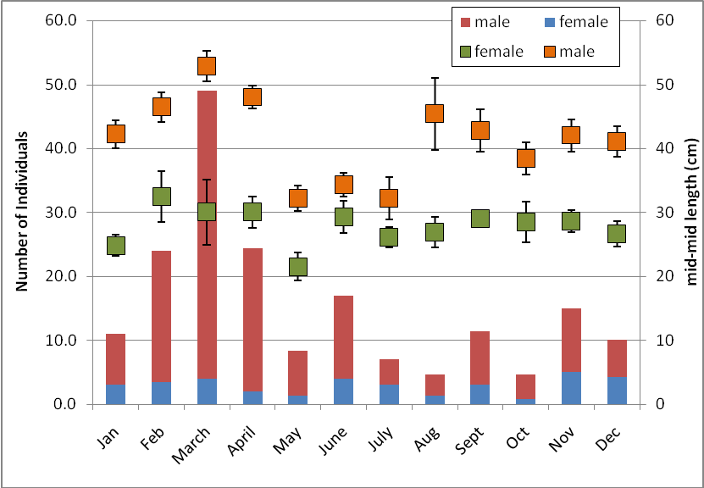

**Figure 19:** Mean abundance (bars) and size (with standard errors) of robber crabs recorded along the back path each month in 2008.

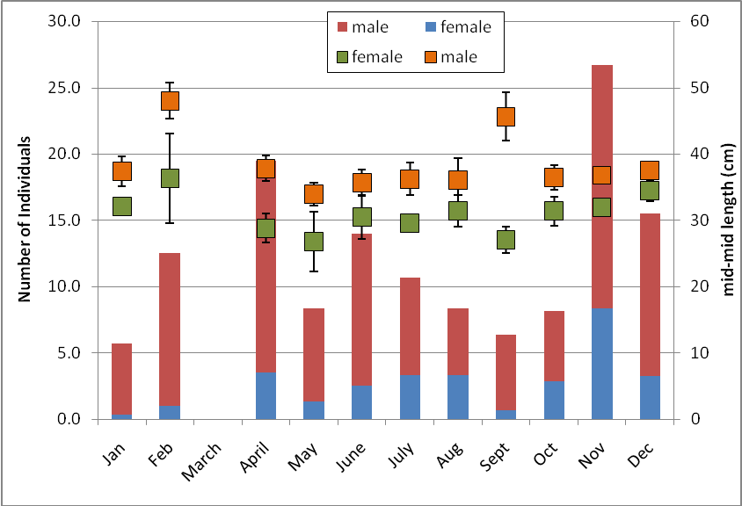

**Figure 20:** Mean abundance (bars) and size (with standard errors) of robber crabs recorded along the coastal path each month in 2008.

# 9.0: Marine Mammals

## 9.1: Dugongs

2008 was not a particularly productive year for recorded sightings of dugongs. On August 2nd an individual was sighted in the vicinity of Bras Monsieur Clairmont by the then RO Gavin Hellstrom, his three children, Senior Ranger Alex Underwood and Ranger/boatman Dereck Louange. This is the only sighting recorded for 2008.

## 9.2: Whales and dolphins

In 2008 the previous sightings and recordings of marine mammals at Aldabra were collated by Aurelie Hermans and Pierre Pistorius. These records were published in the Atoll Research Bulletin No. 564 in November 2008 and highlights the diversity of marine mammals previously recorded in the waters around Aldabra. Fourteen species have been reported with 348 sightings. Humpback whales are amongst the most numerous of these and are commonly recorded from July to November. The first sighting of humpback whales from the research station in 2008 was recorded on June 12th with the number of sightings increasing during July with individuals or groups of individuals sighted almost every day. No formal monitoring or recording of the number of sightings was completed in 2008 and although records of numbers and activity were kept early in the season this was stopped in late July / August. According to monthly reports from the previous RO this was due to the impractical nature of keeping opportunistic records of staff sightings. No formal monitoring was conducted in regards to humpback whales and there are also no consistent or clear records of other marine mammal sightings for 2008 and so it is difficult to present an annual summary of sightings.

The records available at the station indicate that the majority of opportunistic sightings recorded involved groups of 2 -3 individuals which were sighted directly off the research station.

In April 2008 there was a visit to the atoll by Michel Vely who was on board Sea Bird. During this visit Michel gave a presentation to station staff regarding monitoring of humpback whales. He also left a hydrophone at the station to be used for the following humpback season (July – November). There is no record of this being used during the 2008 season apart from a couple of mentions of it in the July monthly report. However, in this report it is stated the hydrophone was used on a number of occasions in attempts to attract whales. This is not the use of a hydrophone which is used to record whale songs and provide an estimate of distance and record song variation.

In the August monthly report increased details of the activity of a number of small groups of humpback whales was reported with on group of 3 adults and a single sub-adult recorded inside the main channel. However, no dates are included and details of all sightings are sketchy and missing important information.

Sightings of other marine mammal species were made throughout the year and in particular pods of Spinner dolphins were regularly seen directly off the Settlement Reef and on subsistence fishing trips. In particular this species was often observed around the main channel however these sightings often go unrecorded and no attempt is made to estimate number of individuals or record the activity of animals on sighting.

On the 29th of November a small pod of killer whales was also sighted in the vicinity of the main channel (Figure 21). This same group of individuals (identifiable due to the distinctive markings on the dorsal fin of one of the males in the group) was again seen on December 8th. While not the first time killer whales have been recorded in water around Aldabra they are not often seen and an article on these sightings was written for the Seychelles Nation written by Bernard Coetzee and Nancy Bunbury and appeared in the paper on the 16th December 2008.

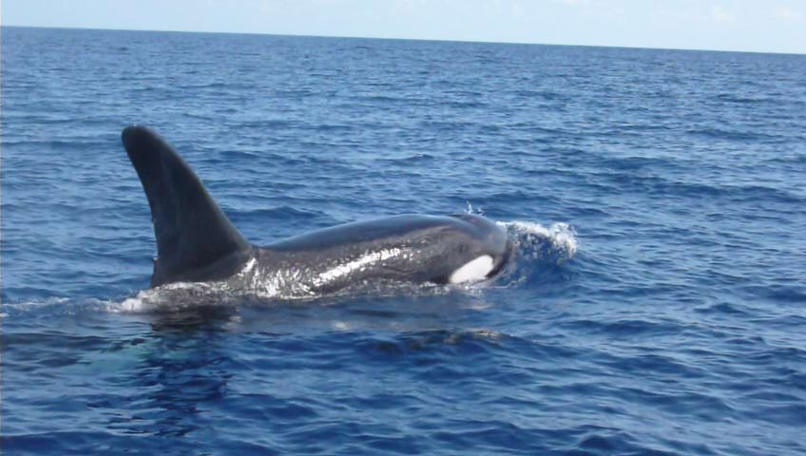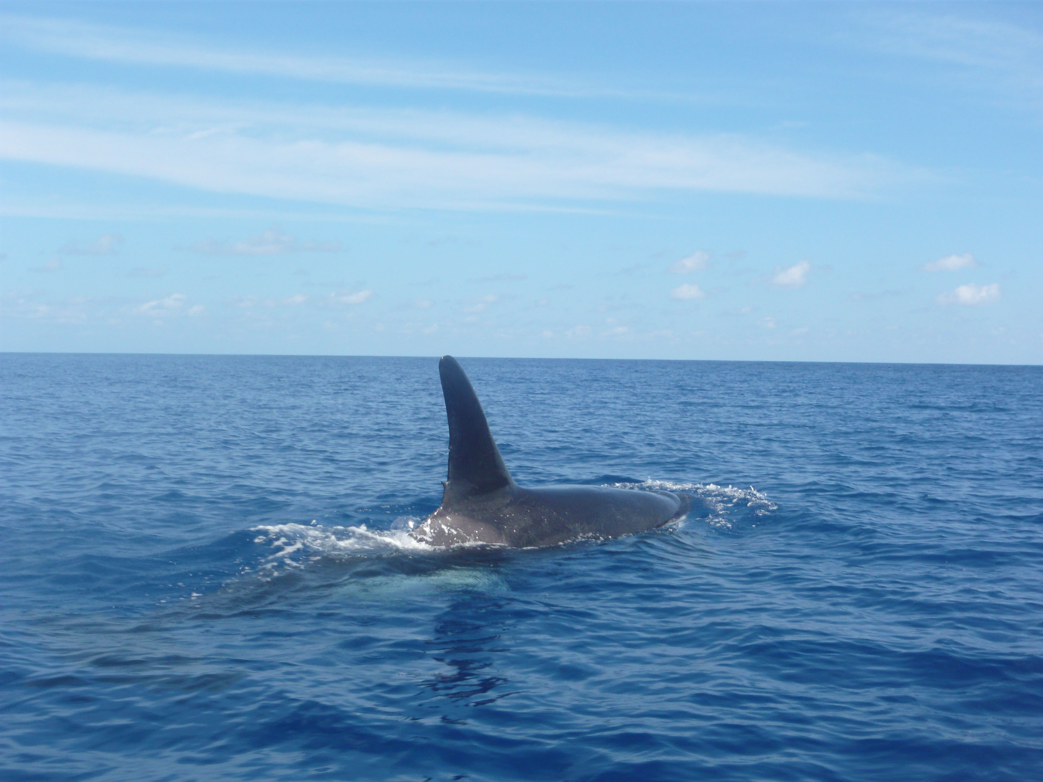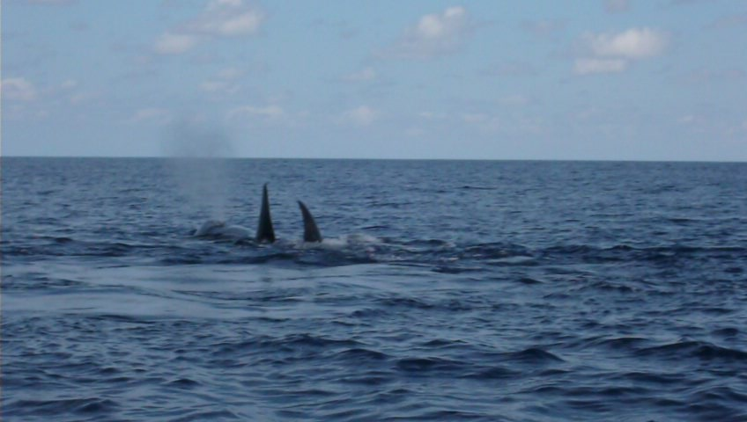

**Figure 21:** Killer whales photographed in the waters adjacent to Aldabra in November and December 2008.

# 10.0: Vegetation Monitoring

Vegetation monitoring has been conducted along the back path on Picard since April 2007. In 2008 this monitoring continued, however, throughout the year there were numerous changes to the monitoring in terms of species included (Table 13) number of specimens and methods and this complicates its reporting. A summary of the monitoring is provided from the RO’s monthly reports from throughout the year.

The first rain of 2008 fell on the 10th of January on Picard and subsequently to this a majority of the plants monitored stayed green and few begun to sprout including *Jasminium elegans, Obetia radula*, *Tricalysia ovalifolia*, or had flower buds (*Allophylus aldabricus, Triainolepsis africana* subsp. *hildebrandtii, Scutia myrtina, Canthium bibracteum*). Other species were found to remain dry after the rain, including *Capparis cartilagena*, *Clerodendrum glabrum* var. *minutiflorum*, *Ochna ciliate, Solanum aldabrense* and *Apodytes dimidiate*.

By February most of the vegetation monitored was green with the majority of the specimens monitored were sprouting at the beginning of the month. Many of these specimens were also flowering while others were bearing fruits. Only 2 of the specimens monitored were found to be dry and these were the same as ones that were dry in January (*Capparis cartilaginea*).

As a response to the rainfall in February and March most plants remained green and many were sprouting fruit. This continued in April.

By May and June the majority of specimens monitored were recorded as being dry, having few if any leaves. Many specimens monitored in June were also recorded as having insect damage, with the same conditions prevailing through July.

Changes to the vegetation monitoring were instigated in August by the new RO and as reported in his September monthly report 33 species of plants were then being sampled along the back path for the plant phenology study, this is 6 more than was originally included in the monitoring when it commenced in April 2007, according to the previous annual report. However, only 4 species are listed as being added by the new RO. It is unclear why these four species were not included in the previous vegetation monitoring as they are relatively common on Picard and along the monitoring transect. I have been unable to locate any details or information in regards to the selection of species for inclusion in the previous vegetation monitoring. A list of species monitored is provided in Table 12.

This particular phenology survey, established by Gavin Hellström and Cathy Avierinos required the recording of complex data on the intensity of flowering, fruiting and leaf growth as well as the presence of pollinators, insect and rat damage, drought effects and fungus infestation. While the scope of the data collected was perhaps appropriate for a detailed and intensive monitoring programme, the quality and quantity of the data collected meant the methods held some limitations. For example, the number of three individuals per species was insufficient for any detailed statistical analysis of the data and, thus, no sound conclusions about the phenology of a species could be drawn from the data collected. The categorisation of flowering, fruiting and leaf budding was overly complicated and fairly subjective, as was the assessment of the intensity of these stages. This resulted in the recording of different categories and intensities for exactly the same conditions on the plant.Despite these complications and the considerable amount of time involved in completion of the transect the plant phenology monitoring programme was continued during October, November and December.

Table 13: Plant species included in the vegetation phenology monitoring along back path during 2008.

|  |  |  |
| --- | --- | --- |
| **Species** | **Included in Original monitoring** | **Species added by new RO** |
| *Acalypha claoxloides* | X |  |
| *Allophylus aldabricus* | X |  |
| *Apodytes dimidiate* | X |  |
| *Azima tetracantha* | X |  |
| *Canthium bibracteatum* | X |  |
| *Capparis cartilaginea* | X |  |
| *Cassipourea lanceolata* (rare) |  |  |
| *Clerodendrum glabrum var. minutiflorum* | X |  |
| *Dracaena reflexa* |  | X |
| *Erythroxylum platycladum* | X |  |
| *Euphorbia pyrifolia* | X |  |
| *Flacourtia indica* | X |  |
| *Gagnebina commersoniana var aldabrensis* |  |  |
| *Grewia picta* | X |  |
| *Jasminium elegans* | X |  |
| *Lomatophyllum aldabrense* | X |  |
| *Maytenus senegalensis* | X |  |
| *Mystroxylon aethiopicum* | X |  |
| *Obetia radula* (rare) | X |  |
| *Ochna ciliate* | X |  |
| *Pandanus tectorius* | X |  |
| *Pemphis acidula* |  | X |
| *Pleurostelma cermuum* |  | X |
| *Polysphaeria multiflora* | X |  |
| *Premna serratifolia* |  | X |
| *Scutia myrtina* | X |  |
| *Sideroxylon inerme subsp. Cryptophlebium* | X |  |
| *Solanum aldabrense* | X |  |
| *Tarenna supra-axillaris* (rare) | X |  |
| *Terminalia boivinii* | X |  |
| *Tournefortia argentea* | X |  |
| *Trianolepsis africana subsp. Hildebrandtii* | X |  |
| *Tricalysia ovalifolia* | X |  |

# 11.0: Goat Eradication Project

The most recent attempt at the eradication of goats on Aldabra commenced in 2007 under a project led by Rainer von Brandis. This eradication took place between mid-July and mid-December and resulted in 202 goats being eliminated by the eradication team. At the completion of the intensive eradication activities in mid-December staff from the research department had been trained in the use of telemetric gear and continued with the location of the Judas goats and the elimination of any identified non-judas goats (Figure 22). A map of locations logged with a GPS as sightings is shown in Figure 23. However, this map does not include all sightings of goats throughout the year. A summary of sightings during 2008 is presented in Table 14.

On the 24th of January the first monitoring of radio-collared Judas goats was undertaken by SIF staff. This was the first of what was to become monthly trips to the Cinq Cases area to track and monitor the remaining 6 Judas goats and identify and remove any non-judas goats associated with them. The information for this section of the annual report has been taken from GEP reports where possible (the first of these available is from May 2008) and summary information presented in the RO monthly reports. The GEP reports provided by Alex Underwood are included in Appendix 1. They have been reformatted for space efficiency but the reports themselves are available on request.

The GEP trip in January located the Judas goats and it became apparent during this trip that 4 of the 6 goats from the Cinq Cases area had joined into one group while the remaining 2 were restricted to the Takamaka area. In February a number of the goats were located in the Anse Cedras area but none of them were sighted.

It was during February that the first sighting of a single female goat occurred in the Dune Jean-Louis area. This individual was sighted again in December and appears to have remained in close proximity to the hut at Dune Jean-Louis. It also appears to be the only individual in this area. In March the four Judas goats that have joined into on apparent group remaining in the Cinq Cases region were sighted and located and no non-judas goats were with them. The 2 goats from the Takamaka region remained in this area and together. During the GEP activities in April several non-judas goats were sighted in the company of the Judas goats. This included 2 juvenile goats and a sub-adult in the Cinq Cases region and a female and young male with the 2 individuals in the Takamaka region.

Efforts on the GEP in July saw the location and sighting of J8 with a single sub adult male in the Takamaka region while J1 which was also previously in this area was not sighted. In the Cinq Cases region J7 and J9 were located and were accompanied by a black adult female and a juvenile. The adult female was subsequently shot. J10 and J12 were also located during July in the company of a kid which was shot during the monitoring.

At the end of July it was believed that there were 8 goats remaining on Aldabra. GEP activities during the month located J1 and J8 with a sub-adult male and J7, J9, J10, J12 with a juvenile. However, this estimate does not address the issue of where the kid had come from or the continued sighting of sub adult goats or pregnant females. It is hoped that the kid sighted in July had come from the black female which was shot but it is possible that it was from another unidentified female.

In August a pregnant female non-judas goat was located with J10 and J12 at Cinq Cases. This again raises the question of where this female had been previously and indicates at least one adult male non-judas goat was present in the area at this time. In addition to the adult female an adult male non-judas goat was also shot in the Takamaka area when it was located with J8. Following the removal of these 2 adult goats no non-judas goats were located in September. The monitoring activities in this month saw the location of all Judas goats.

In October 3 more non-judas goats were located and eliminated, 2 adult females and 1 adult male. The 2 females were both found with the Judas goats in the Cinq Cases area while the male was located in the Takamaka region.

November saw 2 trips to the Cinq Cases are to conduct GEP related activities. On the first of these the 2 Judas goats from the Takamaka area (J1 and J8) were seen at Cinq Cases indicating they have moved north from their previous general location. During the second trip to Cinq Cases in late November 2 non-judas goats were shot, however only one carcass was subsequently located.

December again saw 2 trips to Cinq Cases for GEP related activities. However, a report was only provided on the first of these and no specific details have been submitted on the second. During the second visit 2 non-judas goats were sighted with 2 subsequently shot – 1 adult female and 1 adult male. No details on the third goat have been provided so it is difficult to ascertain if this individual has been seen since. Details provided in the reports in terms of the sex and colour of non-judas goats sighted during November and December make it difficult to follow the number of non-judas goats likely to still be present at the end of the year. In late November 4 non-judas goats were sighted with 2 of these being shot (1 confirmed, 1 not confirmed). In early December one brown female was seen with the Judas goats and subsequently shot. However in late December 3 non-judas goats were recorded, possibly 4. Of the 3 sighted on one day 1 was shot leaving 2 remaining, but no details on colour were recorded and so it is not possible to determine if one of these remaining 2 was indeed the brown male shot on the following day.

The continuation of GEP related activities throughout 2008 has lead to the elimination of 17 non-judas goats since January (Table 14). A map of the locations of goat sightings for 2008 has been produced and is shown in Figure 19. All staff involved in the activities should be commended on their hard work towards continuing efforts to eradicate the goats from Aldabra (Figure 22).

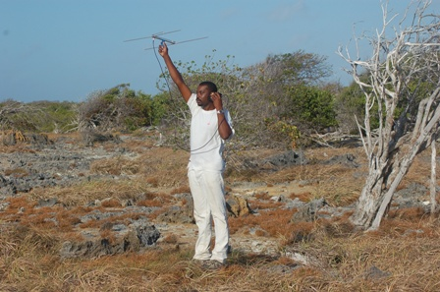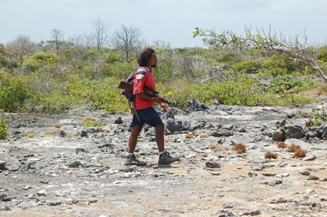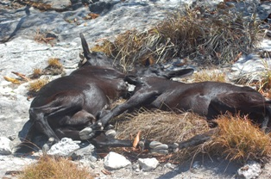

**Figure 22:** Staff conducting GEP activities (Alex Underwood – left, Marc Jean-Baptiste – right) and 2 adult female non-judas goats.

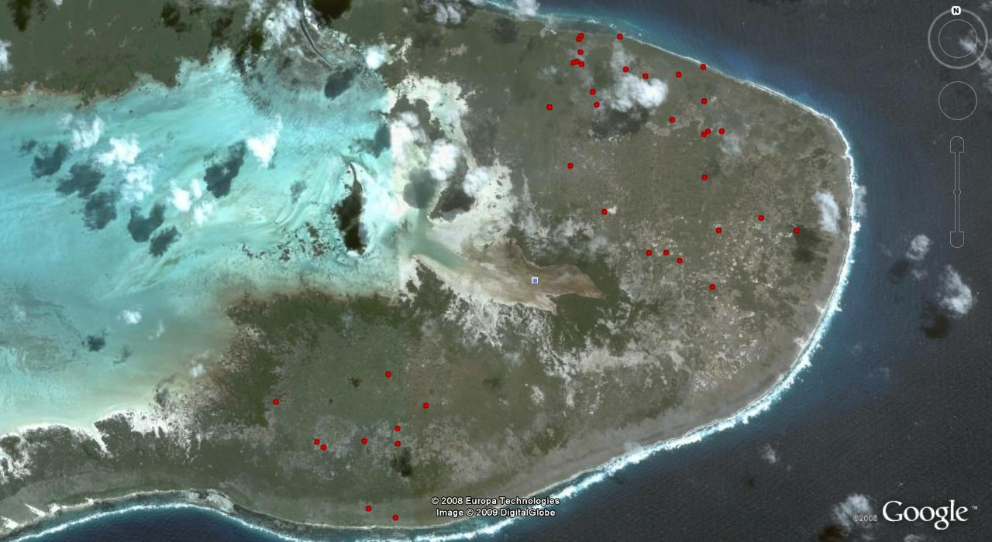

**Figure 23:** Map of the locations of Goat Sightings for 2008.

Table 14: Summary of Goat Eradication Project activities for October – December 2008.

| **Date** | **Region** | **Judas Goat Tracked** | **Judas Goat Associated with** | **Non Judas Goat seen with Judas** | **Non-Judas Goat shot** | **Sex of Goats Shot** | **Notes** |
| --- | --- | --- | --- | --- | --- | --- | --- |
| 24/01/2008 | Cinq Cases | J9 | J7, J10, J12 | NONE | NONE | NA |  |
| 24/01/2008 | Takamaka | J1 | J8 |  |  |  | Goats not seen. Both close together |
| 12/02/2008 | Dune Jean-Louis |  |  |  |  |  | Single brown female of 6-12 months age |
| 23/02/2008 | Cinq Cases | J9, J10, J12 |  |  |  |  | Goats not seen but close together |
| 21/03/2008 | Takamaka | J1, J8 | Together | NONE | NONE | NA | Saw J8 not J1. But together |
| 21/03/2008 | Cinq Cases | J7, J9, J10, J12 | Together | NONE | NONE | NA | All four sighted together, resting |
| 21/04/2008 | Cinq Cases | J7, J9, J10, J12 | Together | 3 | NONE | NA | 2 juvenile black spotted, 1 sub-adult brown |
| 22/04/2008 | Takamaka | J1, J8 | Together | 2 | NONE | NA | 1 brown female, 1 sub-adult male |
| 19/05/2008 | Takamaka | J1, J8 | Together | 5 | 3 | 2 male,  1 female | Shot 2 brown adult males, 1 brown adult female  1 brown adult female, 1 black/white adult male escaped |
| 20/05/2008 | Cinq Cases | J7, J9 | Together | 1 | 1 | Male | 1 brown sub-adult male shot, J10, J12 not seen |
| 17/06/2008 | Takamaka | J8 |  | 2 | 1 | Female | 1 adult brown female shot, black/white male escaped |
| 17/06/2008 | Takamake | J1 | Not located |  |  |  | No clear signal |
| 18/06/2008 | Cinq Cases | J10, J12 | Together | 2 | 1 | female | 1 pregnant brown female shot, 1 adult black male escaped |
| 18/07/2008 | Takamaka | J8 |  | 1 | NONE | NA | 1 black/white adult male, J1 not sighted |
| 19/07/2008 | Cinq Cases | J7, J9 | Together | 2 | 1 | female | 1 black adult female shot, 1 juvenile escaped |
| 20/07/2008 | Cinq Cases | J10, J12 | Together | 1 | 1 | female | 1 female kid shot |
| 18/08/2008 | Cinq Cases | J10, J12 | Together | 1 | 1 | female | 1 pregnant female shot |
| 18/08/2008 | Cinq Cases | J7 |  | NONE | NONE | NA | J7 sighted and alone, J9 not seen |
| 19/08/2008 | Takamaka | J8 |  | 1 | 1 | male | 1 black/white adult male shot, J1 not sighted |
| 15/09/2008 | Takamaka | J8 | J1 | NONE | NONE | NA |  |
| 16/09/2008 | Cinq Cases | J10 | J12, J7, J9 | NONE | NONE | NA |  |
| 13/10/2008 | Takamaka | J8 | J1 | 1 | 1 | Male | 1 male goat shot |
| 14/10/2008 | Cinq Cases | J10 | J12, J7, J9 | 2 | 2 | Female | 2 female goats shot |
| 12/11/2008 | Cinq Cases | J8 | J1 | 1 | NONE | NONE | J1, J8 (from Takamaka) at Cinq Cases with 1 brown adult |
| 13/11/2008 | Cinq Cases | J8 | J1 | 2 | NONE | NONE | With J1 and 2 non-judas goats, J7, J9, J10, J12 not tracked |
| 22/11/2008 | Cinq Cases | J8 | J1, J7, J9, J10, J12 | 4 | NONE | NONE | Unable to shoot any Non-Judas Goats |
| 23/11/2008 | Cinq Cases | J8 | J1, J7, J9, J10, J12 | 4 | 2 | Male, unknown | carcass of the 2nd goat shot was not located |
| 24/11/2008 | Cinq Cases | J8 | Unknown | Unknown | NONE | NONE | Appears to be one non-judas goat only |
| 02/12/2008 | Dune Jean-Louis |  |  | 1 | NONE | Female | 1 adult brown female |
| 16/12/2008 | Cinq Cases | J8 | J1, J10, J7 | NONE | NONE | NONE | J9, J12 not sighted |
| 25/12/2008 | Cinq Cases | J8 | J1, J7 | NONE | NONE | NONE |  |
| 25/12/2008 | Cinq Cases | J10 | J9, J12 | 3 | 1 | Female | 1 black female shot |
| 27/12/2008 | Cinq Cases | J10 | J9 | 1 | 1 | Male | 1 brown male shot |

# 12.0: Departmental Issues

## 12.1: Staff

As I only arrived on the atoll in November it is rather difficult to write this section of the annual report and I have done my best to compile details of the many staff changes that occurred in the research department during 2008 (Table 15). Most notably was the changes in staffing in the position of Research Officer and 2008 saw this role filled by three people, for varying lengths of time and it also saw a number of months pass with no research officer. The role of Assistant Research Officer was filled by two people throughout the year with Aurielie Hermans filling this position until March and Ian Valmont taking on the position from September for the remaining part of the year. Aurelie was the first person to fill this position which was newly created in 2007.

Much of 2008 saw the research department operating with minimal staff and very few people to assist with the completion of monitoring activities. During this time a great deal of assistance was provided by the Island Manager, Marc Jean-Baptiste and boatman Dereck Louange. It is difficult to comment on the general morale of staff throughout the year; however, on my arrival it seemed generally positive despite the many staff changes and the abrupt resignation and departure of Gavin Hellstrom.

As noted in the 2007 annual report the demands on staff within the research department shifts dramatically between the seasons with increasing tourist and visitor numbers this will only become more apparent as noted in numerous monthly reports.

Table 15: Name, position and engagement of research staff at the Aldabra Research Station.

|  |  |  |
| --- | --- | --- |
| **Name** | **Post** | **Engagement** |
| Pierre Pistorius | Research Officer | January - April |
| Gavin Hellstrom | Research Officer | July - November |
| Naomi Doak | Research Officer | November - December |
| Aurilie Hermans | Assistant Research Officer | January - March |
| Ian Valmont | Assistant Research Officer | September – December |
| Alex Underwood | Senior Ranger | January – December |
| Catherine Onezia | Ranger | January |
| Edwina Jean-Baptiste | Ranger | January |
| David Boodna | Ranger | December |
| Devis Monthy | Ranger/Boatman | January - March |
| Ritval Pillay | Exchange Ranger | September - December |
| Stan Denis | Trainee Ranger | December |
| Bennet Crispin | Trainee Ranger | July - December |
| Amanda Northrop | Volunteer | January – May – Barcoding Fishes of Aldabra |
| Rowan Yearsley | Volunteer | January – May - Barcoding Fishes of Aldabra |
| Jennifer Stockdale | Volunteer | November – December – Madagasca Pond Heron |
| Rebecca Scott | Volunteer | November – December – Turtle project |
| Bernard Coetzee | Volunteer | November – December - RAMSAR application |

## 12.2: Rangers Projects

Some details of rangers personal projects are included in the monthly reports from 2008. However, there appear to be no final reports on any of the projects and it remains unclear if any of them were completed. Summaries from the projects started by rangers are included below with details taken from the monthly reports. I have not been able to locate any project outlines or proposals on the computers here in regards to the rangers projects and am unsure if they were sent to the Scientific Committee for comment or approval.

**Greater Flamingos – Catherina Onezia**

Catherina compiled records of previous sightings of flamingos and continued observations and records where possible. Sightings of individuals were recorded in the monthly reports and details obtained from the notes on Catherina’s project have been included in Table 12 in the Bird section of this report.

**Abundance, distribution, size range and habitat association of sea cucumbers around Aldabra – Devis Monthy**

No details of this project were reported in the January monthly report and the project was discontinued in February as no progress had been made on it for several months and Devis was completing his contract in the research department and returning to Mahé.

**The impact of rats on the Vegetation on Picard – Alex Underwood**

This project is only mentioned in one of the monthly reports and no details are provided or included.

The March annual report for 2008 details attempts by two of the research staff – Alex Underwood and Devis Monthy – to digitize a list of the books held in the library at the research station. However, I have been unable to locate a completed version of this information.

Catherina Onezia also made considerable efforts towards entering all of the event cards into a digital event card system. These efforts saw the majority of event cards in the library entered into a digital system, however, further work is required to complete this task and ensure that all future event cards are also entered into this system.

## 12.3: Volunteer Projects

The start of 2008 saw the arrival of 2 volunteers, Amanda Northrop and Rowan Yearsley, on the atoll to undertake fieldwork for a project entitled “Biomaterial Banking and Barcoding – Fishes of Aldabra”. This project was undertaken through the South African Institute for Aquatic Biodiversity (SAIAB) and involved the two volunteers collecting specimens of as many of the fish species found on Aldabra as possible. Specimens were collected with the use of either a gill net or with hand-nets and a DNA sample was then removed from the specimens and placed in ethanol with a unique code or identifier. The remainder of the fish was used as a voucher specimen and was stored in a freezer until transfer to Mahé was possible. The voucher specimen was then fixed in formalin and accessioned into the National Fish Collection at SAIAB (together with all the DNA and Images).

The specific objectives of the study were as follows:

* To provide baseline specimen vouchers and DNA collections of the marine fish species of the Western Indian Ocean for taxonomy and curation. Voucher specimens will be provided for both the Seychelles Island Foundation and the SAIAB National Fish Collection.
* Sequence as many fish species as possible using the mitochondrial Cytochrome Oxidase I (COI) for the SAIAB/SIF Barcode of life project (Fishes of Aldabra Island) for species identification

# Products from the study were to include:

* A registered fish barcoding project between the SIF, SFA and SAIAB that will be managed by these institutions and will not be available to the public
* Comparative COI genetic sequence data of various tropical Western Indian Ocean regions e.g. the Seychelles (Aldabra), and South African fishes.
* Voucher specimens accessioned into the SAIAB National Fish Collection together with images and DNA for some/all species. A voucher specimen of each species that is collected will be given to the Seychelles Island Foundation, along with copies of all images and data on species, sequences etc.
* Accessioned COI sequences and specimens for the Barcode of Life project.
* Species diversities and phylogenetic studies to be performed in conjunction with data from other WIO regions.

We are still awaiting a final report on this project and as yet to my knowledge no voucher specimens, DNA data or images have been provided to SIF. After contact was made with the primary investigators, Dr Monica Mwale, involved in this project additional detail was sent including a list of samples collected, voucher ID, neighbour joining tree of the specimens collected and a CD with images of fish collected.

Bernard Coetzee arrived on the atoll in November and started work on the nomination of Aldabra as a RAMSAR wetland site. Bernard left the atoll earlier than planned in January 2009 and this application was completed by Nancy Bunbury and has been submitted to RAMSAR.

Other projects undertaken by volunteers on Aldabra in 2008 included the commencement of a project investigating the “Population status and breeding ecology of the Madagascar pond heron *Ardeola idae* on Aldabra Atoll.” This project commenced in November 2008 and was primarily undertaken by Jennifer Stockdale. The project is continuing in 2009 and a report on the fieldwork conducted to date will be included in the 2009 Annual Report. A summary of the aim of the project is included below.

The endangered Madagascar pond heron (MPH) *Ardeola idae* is a migratory species with a large non-breeding distribution but a small total population of approximately 6000 birds which is known to be declining. Severe combined threats of wetland habitat deterioration and destruction, and exploitation by humans of eggs and young are driving population decline across much of the MPH’s breeding range in Madagascar and the Comores. At some sites the MPH has declined with alarming speed to a few or no birds in just a few years (MPH Action Plan 2008). These threats are compounded by the fact that very little is known about this species in the wild. The only MPH breeding site not facing these threats is Aldabra Atoll, a protected UNESCO World Heritage site in the Seychelles archipelago. Aldabra may constitute a population stronghold and important breeding site for the MPH at a time when the species appears to be declining almost everywhere else. Despite this, no research has so far been conducted on the MPH on Aldabra. The project will initiate a long-term monitoring and research programme on the species. Overall, the project aims to bridge this gap in the knowledge of an endangered and declining species at a relatively undisturbed site which is likely to offer what is effectively the best protection across its range. In addition this project will address several key aspects of the recently developed MPH Species Action Plan and pioneer conservation work on this species by:

1. Mapping MPH distribution and estimating the population size on Aldabra;
2. Surveying breeding MPHs by nest searches on foot and by boat;
3. Determining MPH breeding success and causes of nest failure over (at least) two breeding seasons;
4. Investigating breeding MPH habitat requirements and preferences
5. Examining adult foraging ecology

Rebecca Scott commenced a project investigating the influence of tides and habitat diversity within the Aldabra lagoon on sea turtle foraging stocks in November 2008. The aim of the project was to determine the influence of tides and habitat characteristics on the foraging stock composition and behaviour of sea turtles within the Aldabra lagoon. Baseline information was to be collected to gain insights into the health of both foraging and nesting turtles and hatching success on key nesting beaches around the atoll.

The initial project proposed by Becky included:

* Investigation into how tides and habitat characteristics govern the abundance and movements of adult and juvenile green and hawksbill sea turtles within the lagoon.
* Collect baseline information on the health of sea turtles foraging and nesting in Aldabra.
* Collect baseline information on hatching success and how accurately this can be determined to facilitate any future work on this topic.

Project Outputs were planned to include:

1. Project report within 2 months of the end of field work
2. Possible publication depending on amount and quality of data collected
3. Recommendations for future research (to be included in project report) – especially in the areas of hatching success and turtle health.
4. Baseline data on hatching success, turtle health and foraging stocks – will enable changes to sea turtle populations over subsequent years to be detected.
5. Training of SIF staff in field techniques – including methods of monitoring turtle hatching success and health.

Similar to the work on the pond heron this project was ongoing at the end of 2008 and the final report provided by Becky will be included in the annual report for 2009.

## 12.4: Visiting Scientists

The 2008 annual report sees an increase in the size of the section related to visiting scientists. It has also seen a renewed effort to ensure that reports from groups conducting research expeditions to Aldabra are submitted both to the SIF office on Mahe but copies also sent to Aldabra for future reference. Efforts to obtain reports from 2008 are ongoing. Details of groups that visited the atoll for research purposes and summaries of the purpose of their visit are included below.

**SOPTOM Expedition – Gonfaron, Bernard Devaux**

Ten French scientists arrived on the atoll on the 5th of February and departed on the 19th. The main purpose of their visit was to look into the possibility of doing a tortoise population census using a balloon and kite. The idea was to mark tortoises with large pieces of coloured tapes and peg out known quadrat sizes then using a camera tied to a balloon which could be controlled they would be able to get data that would allow a tortoise population census. The census would be conducted using a boat going on the outside circumnavigating the atoll and at the same time having the airborne camera filming.

Unfortunately an accident on the way over from Assumption compromised their project and they also found the wind too strong for the balloon and as a result most of their time on the atoll was spent doing photo reportage. They also wanted to film behaviour of tortoises that display group behaviour i.e. all going to eat at the same time or going to find shade simultaneously.

Details of their time on Aldabra are published in an article in the August 2008 edition of the La Tortue Magazine.

**IUCN research team**

An IUCN led team of 5 people arrived on the atoll on 29th March and stayed until 6th April as part of a reef resilience study. Information on benthic cover as well as fish composition was collected from several sites around the atoll to assess resilience of the reef system. A resulting report from IUCN states that a better assessment of the threats to coral reefs along with improved management will give corals a much higher chance of survival in the face of warming oceans.  
  
The report, Resilience Assessment of Coral Reefs - Rapid assessment protocol for coral reefs, focusing on coral bleaching and thermal stress, shows that the amount of damage done to corals depends not only on the rate and extent of climate change, but also on the ability of coral reefs to cope with change. This report outlines a protocol that defines basic resilience indicators that can be quantified using rapid assessment methods.  
  
The report can be downloaded at <http://cmsdata.iucn.org/downloads/resilience_assessment_final.pdf>

**Save Our Seas**

Five Save Out Seas (SOS) members and 3 support staff arrived on 12th march, departing 10th April. Primary aims of this visit were to document shark species around Aldabra and to obtain images for the Aldabra Foundation exhibit. While no report on the visit by SOS is available a blog was kept during their time on Aldabra and is available at http://www.saveourseas.com/Aldabra.

**Eco School visit**

From the 22nd – 31st March the island hosted the annual Eco School visit. In 2008 this included a number of French students and photographers in addition to the students from schools on Mahe. The visit also featured as a news item on SBC on 6th April and as a centre page article in the Nation Newspaper on 12th April.

**Phlebemos Project**

This project involved research that contributes to a project on Insect Vectors (Phlebotomines and Mosquitoes) in the Islands of the Indian Ocean: Madagascar, Seychelles and Comoros. This research group included four people and involved sampling of insects around the atoll at a number of the field camps. The group arrived on IOE on the 12th of December and included Gerard Rocomora, Vincent Robert, Simon Julienne and Steve Goodman.

Dr. Steve Goodman was one of the people involved with this work and he also spent time mist-netting for the small micro-bats (insectivorous bats) recorded on the atoll. He was successful in recording, catching and sampling tissue from one of the 3 species. Samples from another of the 3 species have since been collected and sent to Steve for analysis. Details of this will be included in the 2009 annual report.

**Aldabra Marine Program (AMP)**

The AMP researchers arrived on IOE at the same time as the Phlebemos Project. Reaching Aldabra on December 12th Nigel Downing and Rodney Quatre began the marine survey work at a number of established sites around the atoll looking at coral cover and fish species diversity and abundance. Ray Buckley and Ben Stobart joined the group on the 19th for a number of days diving on more of the established sites around the atoll before departing for further work on Assumption and other nearby islands on the 22nd. During their stay both Nigel and Rodney spent a couple of nights based at the station with logistical support provided by SIF staff.

**TV Arte**

Jean Fromant and Jerome Perrault from TV Arte were also present on the atoll during the visit of researchers with the Phlebemos project filming footage for a documentary for French Television on the Atoll.

## 12.5: Visiting Vessels

2008 saw a significant number of tourist vessels visiting the atoll and the total number of visitors was significantly greater than in previous years. In total almost 1700 visitors came to Aldabra in 2008 with a number of vessels having repeat trips to the region (Table 16). The year also saw the arrival of Europa for a short visit to the atoll. On board were 400 guests and a large number of staff. This visit went surprisingly well and guests were divided into small groups for tours with consecutive groups heading in different directions in an attempt to limit congestion on paths and overlap of groups.

Table 16: Vessels visiting Aldabra research Station.

|  |  |  |  |
| --- | --- | --- | --- |
| **Date or arrival** | **Date of departure** | **Vessel** | **Passengers** |
| 7/01/2008 | 8/01/2008 | Island Sky | 86 |
| 8/01/2008 | 10/01/2008 | Indian Ocean Explorer | 9 |
| 15/01/2008 | ? | Indian Ocean Explorer | 9 |
| 13/01/2008 | 14/01/2008 | Le Ponant | 30 |
| 28/01/2008 | 29/01/2008 | Island Sky | 80 |
|  |  |  |  |
| 5/02/2008 | 8/02/2008 | Visiting Tourists – stayed at Station | 8 |
| 7/02/2008 | 9/02/2008 | Island Sky | 80 |
| 8/02/2008 | 9/02/2008 | Le Ponant | 60 |
| 19/02/2008 | 21/02/2008 | Island Sky | 60 |
| 21/02/2008 | 22/02/2008 | Cuor di Leone & Sea Fever | 15 |
| 27/02/2008 | 29/02/2008 | Cuor di Leone & Sea Fever | 20 |
|  |  |  |  |
| 2/03/2008 | 3/03/2008 | Le Ponant | 81 |
| 4/03/2008 |  | Water World | 60 |
| 7/03/2008 | 8/03/2008 | S.Y Anaho Sailing Cat | 11 |
| 13/03/2008 | 15/03/2008 | Le Ponant | 81 |
| 16/03/2008 | 19/03/2008 | M.S. Suheyla Sultan | 10 |
| 17/03/2008 | 19/03/2008 | S.Y. Hetairos | 9 |
| 17/03/2008 | 18/03/2008 | Island Sky | 90 |
| 20/03/2008 | 21/03/2008 | Coco Sailing Cat | 6 |
| 23/03/2008 | 01/04/2008 | Eliza Sailing Cat | SOS Group |
| 24/03/2008 | 25/03/2008 | Le Ponant | 76 |
| 27/03/2008 | 30/03/2008 | Sea Bird | 14 |
| 31/03/2008 | 2/04/2008 | Sea Bird | 14 |
|  |  |  |  |
| 6/04/2008 | 7/04/2008 | S.Y. Anaho Sailing Cat | 6 |
| 7/04/2008 | 10/04/2008 | Sea Bird | 12 |
| 14/04/2008 | 15/04/2008 | Nautitech 82 - Neptune | 16 |
| 30/04/2008 | 5/05/2008 | Escape Sailing Cat | 7 |
|  |  |  |  |
| 29/09/2008 | 01/10/2008 | Indian Ocean Explorer | 19 |
|  |  |  |  |
| 17/10/2008 | 19/10/2008 | Indian Ocean Explorer | 22 |
|  |  |  |  |
| 11/11/2008 | 11/11/2008 | Hanseatic | 157 |
| 11/11/2008 | 11/11/2008 | Hebridean Spirit | 61 |
| 17/11/2008 | 19/11/2008 | S.Y. Emotion II | 5 |
| 19/11/2008 | 19/11/2008 | Europa | 400 |
| 26/11/2008 | 29/11/2008 | Sea Bird | 24 |
|  |  |  |  |
| 2/12/2008 | 5/12/2008 | Sea Bird | 24 |
| 27/12/2008 | 31/12/2008 | Louann | 10 |

## 12.6: Poaching reports

The available monthly reports from 2008 provide few if any details of patrols around the atoll to detect poaching or any other illegal activities within the waters around Aldabra. The August monthly report details a visit by the yacht Blue De Nimes which had no received clearance or sought permission to moor within the 1km protected area around the atoll. There is also no follow up information on this incident. However, it is understood that the vessel and captain have received a ban from visiting Aldabra.

On one occasion a fishing tender accompanying S.Y. Seabird was observed fishing within the 1km protected area. Contact was made with the crew on board and they were advised to pull in their lines and relocate outside the protected area if they wished to continue fishing and did not wish to be asked to leave the atoll immediately. This incident was reported to the Mahé office as well as to the captain on board S.Y. Seabird and the regulations were clarified with both the captain and the agent. Crew on board the vessel included Bernard Marie who had previously been employed on that atoll and suspected of being involved in poaching on his departure and return to Mahé in 2007.

## 12.7: Logistics / Incident reports

On February 5th during the transport of the SOPTOM Scientists from Aldabra to Assumption the boat Alena ran aground on the reef off the southern coast of Grand Terre. Fortunately no one was injured although the boat sank on the reef after taking in considerable amounts of water. Full reports were provided to the office in regards to this incident.

December saw an unfortunate incident between a staff member on the atoll, Exchange Ranger Ritval Pillay and a volunteer Bernard Coetzee. A full report on the altercation between them was provided and appropriate disciplinary action taken against Ritval who returned to Mahé on the next available transport and his contract was terminated early.

# 13.0: Publications

Born O., Fertard B. & Bonin F. 2008. Port-Folio sur Aldabra. SOPTOM – La Tortue.80: 32-44

Devaux B. 2008. Avis de tempete sur Aldabra. SOPTOM - La Tortue. 80: 4-31

Dupre A. 2008.Exposition parisienne sur Aldabra. SOPTOM - La Tortue. 80:44-46

Goodman SM & Ranivo J. 2008. A new species of Triaenops (Mammalia, Chiroptera, Hipposideridae) from Aldabra Atoll, Picard Islands (Seychelles). Zoosystema 30(3): 681-693

Hermans A & Pistorius P. 2008. Marine mammal diversity in the remote waters of Aldabra Atoll, Southern Seychelles. Atoll Research Bull. (564): 1-6

IUCN reef resilience kit

Pistorius P. 2008. Grey heron (*Ardea cinerea*) predation on the Aldabra white-throated rail (*Dryolimnas cuvieri aldabranus*). Wilson J. Ornithol. 120(3): 631-632

Pistorius PA & Taylor FE. 2008. Abundance, trends and seasonal occurrence of Palearctic waders on Aldabra, Indian Ocean. Wader Study Group Bull. 115(2):84-90

Pistorius PA & Taylor FE. 2008. Population status and conservation of crab plovers *Dromas ardeola* on Aldabra, Indian Ocean. Wader Study Group Bull. 115(1):36-40

Wanless RM & Hockey PAR. 2008. Natural history and behaviour of the Aldabra rail (*Dryolimnas [cuvieri] aldabranus*). Wilson J. Ornithol. 120(1): 50-61

# 14.0: Appendices

# Appendix 1

## GOAT MONITORING REPORT – May 2008

## TAKAMAKA REGION

Date: 19th May 2008

Personnel: Alex Underwood, Marc Jean-Baptiste

Time of departure: 05:40

Time located Judas goats: 08:35

G.P.S: S 09’26.208, E 046’27.420

* J1 and J8 were both located at the above G.P.S co-ordinate, with five other goats. Three were shot and two escapes.
* Two brown adult males and one brown adult female were shot. One of the male and the female die instantly, but the other male was relocated about 200m from the shooting site with gunshot wound in the stomach. The wounded male proceeds with great pain on approaching and found to be bleeding. The wounded male was also seen mating with the shot female prior to shooting.
* The two remaining goats that were not shot were one brown sub-adult male and one black/white adult female. The female is the same one that was sighted last month.

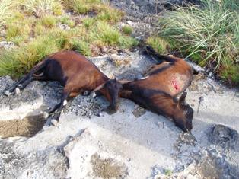

***TAKAMAKA GOATS***

## CINQ CASES REGION

Date: 20th May 2008

Personnel: Alex Underwood, Marc Jean-Baptiste

Time of departure: 05:30

First Sighting

J7 was sighted 12:23 hours at G.P.S co-ordinate S 09’23.596; E 046’29.148 and being alone, the mentioned goat came within two meters.

Second Sighting

J9 and J7 were sighted 13:30 hours at G.P.S co-ordinate S 09’23.205; E 046’28.962 and they were in the company of one goat.

The Non-Judas goat was a brown sub-adult male. The Judas goats were very alert and they were protecting the Non-Judas goat at all time (flank). We even sat for two hours watching then resting, therefore to get a clear shot but it was in vain.

Third Sighting

While returning to Cinq Cases hut from Anse Cedres they were re-sighted at G.P.S co-ordinate S 09’23.224; E 046’29.034 and the Non-Judas goat was shot immediately.

The mentioned goat was shot at 17:45 hours.

NOTE: J10 and J12 were not seen.

## GOAT MONITORING REPORT – June 2008

**TAKAMAKA REGION**

**Date:** 17TH June 2008

**Personnel:** Alex Underwood, Marc Jean-Baptiste

**Time of departure:** 05:00hrs

**First sighting**

* J8 was located at 09:45hrs with two Non-Judas goats
* The two Non-Judas goats are the same one that was missed last time.

As specified in the last report one brown male and one black/white female were seen, but just to confirmed that the former was actually a female and the latter was a male.

**Second sighting**

* The above mentioned goats were relocated at 13:00hrs at G.P.S coordinate S09’26.398, E046’27.148
* The female was shot and found dead about 90 meters from shooting site.
* The black/white male goat was not shot because it was not in a clear position for shooting.
* J1 was not seen. We do not obtain a clear signal when tracking

**CINQ CASES REGION**

Date: 18/06/2008

Personnel: Alex Underwood, Marc Jean-Baptiste

Time of departure: 06:00hrs

* J10 and J12 were located at G.P.S coordinate S09’23.923, E046’30.108 with two other Non-Judas’s goats.
* The Non-Judas goats were one adult brown female and the second one was a black adult male.
* The female was shot at 17:00hrs at G.P.S coordinate S09’23.316, E046’30.142.
* The shot female was probably pregnant.
* The goats were always moving in dense vegetation.
* J7 and J9 were not sighted and it was getting late to track them

Note:

Sighted Non-Judas goats that are still at large are:

* One black/white male at Takamaka
* Two juveniles and one Black adult male at Cinq case

## GOAT MONITORING REPORT - JULY 2008

## TAKAMAKA REGION

**Date:** 18 JULY 2008

**Personnel:** Alex Underwood, Marc Jean-Baptiste

**Time of departure:** 05:00hrs

J8

First sighting

* J8 was seen with one sub-adult male goat at G.P.S coordinate S09’26.493, E046’26.837, 09:15

Second sighting

* Relocated at G.P.S coordinate S09’26.090, E046’26.055 @ 11:49

Third sighting

* Relocated at G.P.S coordinate S09’27.101, E046’26.837 @18:30
* The Non-Judas goat was too close to J8 and both goats were always moving which made it difficult to have a clear shot.
* The second sighting was in dense vegetation, hence made it hard to have a clear target. For the third sighting it was getting to late, therefore we had to abandon as they were re-entering thick “pemphis”.

J1

* J1 was not sighted again this month. No clear signal was obtain while tracking.

**CINQ CASES REGION**

Date: 19/07/2008

Personnel: Alex Underwood, Marc Jean-Baptiste

Time of departure: 08:00hrs

J7 & J9

* The two Judas goats were located @11:55 at G.P.S coordinate S09’23.776, E046’29.827 with two other goats.
* The Non-Judas goats were one black adult female and one juvenile.
* The black adult female was shot and the other escape due to its proximity with the Judas goats.

Date: 20/07/2008

Personnel: Alex Underwood, Marc Jean-Baptiste

Time of departure: 06:00hrs

J10 & J12

First sighting

* Both Judas goats were sighted @ 09:09hrs at G.P.S coordinate S09’24.564, E046’29.157 with one other goat.
* The Non-Judas goat was a kid and was being protected by the Judas goats.

Second sighting

* Relocated @12:15 at G.P.S coordinate S09’24.967, E046’29.698

Third sighting

* Relocated @ 14:10 at G.P.S coordinate S09’24.796, E046’30.189.
* The kid was shot at the above G.P.S coordinate.

## GOAT MONITORING REPORT - AUGUST 2008

**CINQ CASES REGION**

Date: 18th August 2008

Personnel: Alex Underwood, Marc Jean-Baptiste

Time of departure: 06:30hrs

J10 & J12

* Both Judas goats were first sighted at G.P.S coordinate S09’25.046, E046’29.816 around 09:40hrs.
* On first sighting they escape after noticing our present.
* The Judas goats were seen with a female goat.
* The Judas Goats were relocated again around 10:28hrs and still with the same goat.
* The Non-Judas goat was shot at G.P.S coordinate S09’24.959, E046’29.540.
* The Non-Judas goat was pregnant.
* Fetus fully developed as shown in the photo.

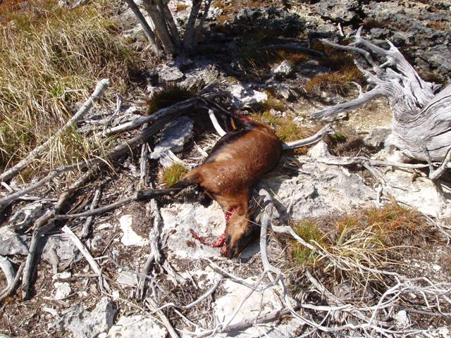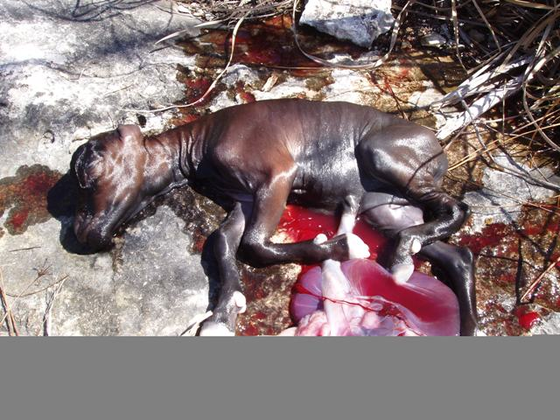

*Fetus – Cinq cases*

*Cinq cases - Female*

J7 & J9

* J7 was sighted at G.P.S coordinate S09’24.844, E046’30.898.
* J7 was seen at 13:30hrs and being alone.
* J9 was not seen this month.

**TAKAMAKA REGION**

**Date:** 19th August 2008

**Personnel:** Alex Underwood, Marc Jean-Baptiste

**Time of departure:** 06:00hrs

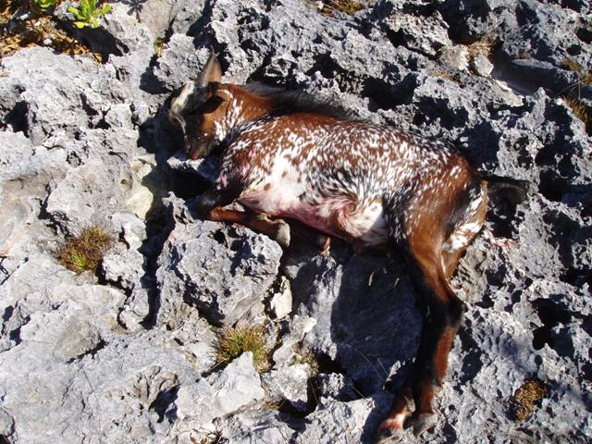

J8

* The above Judas goat was sighted at G.P.S coordinate S09’27.200, E046’27.078.
* We had to cross thick Pemphis to reach J8 which was located on the coast.
* J8 was seen with a male goat at 15:25hrs.
* The Non-Judas goat was shot.

*Male Goat - Takamaka*

J1

* The above Judas goat was not sighted.
* J1 was track each time any other Judas goats were being tracked.
* At Takamaka we started by tracking for J1 prior for doing same with J8.
* Tracking device has been brought to the station so that J1 can be track at Dune Jean Louis.

## GOAT MONITORING REPORT - SEPTEMBER 2008

**TAKAMAKA REGION**

**Date:** 15th September 2008

**Personnel:** Alex Underwood, Marc Jean-Baptiste

**Time of departure:** 05:15hrs

**J8**

* Came within twenty meters of its location around 08:45hrs but was unable to determined if any Non-Judas goats were present as J8 was moving fast among the thick vegetation.
* Scanning of J1 was done; a weak signal was heard on the telemetric device.
* They were able to extend their distance from us. No G.P.S coordinates were taken.
* Relocated again around 10:40hrs at G.P.S coordinate S09’26.527; E046’26.463
* J1 was seen with J8 and no other goats found.
* J1 was last seen on the 19th May with J8.
* With the situation at present, it is most likely that there are no other Non-Judas goats at Takamaka.

**NOTE**

* Telemetric cable was damaged prior confirming the present of both Judas goats.
* The rifle with serial number CAT 4835 243 WIN 26464 BP was damaged. Ranger (A. Underwood) accidentally fell on champignon after locating the Judas goats. No bodily injury sustained. The rifle rear sight was broken and front rim of telescope had bent inward.

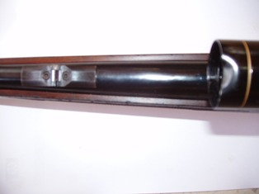

***BEND FRONT RIM***

***BROKEN REAR SIGHT***

***BROKEN CABLE***

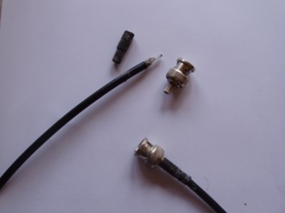

**CINQ CASES REGION**

Date: 16th September 2008

Personnel: Alex Underwood, Marc Jean-Baptiste

Time of departure: 05:10hrs

**J10**

* Sighted around 07:45hrs at G.P.S coordinates S09’24.708; E046’30.584.
* J12, J7, J9 were seen with J10.
* No Non-Judas goats found.

**NOTE**

Monitoring needs to be done continuously to ascertain if in case there is a kid still at large.

**GOAT MONITORING REPORT** - **OCTOBER 2008**

**TAKAMAKA REGION**

**Date:** 13th October 2008

**Personnel:** Alex Underwood, Ian Valmont

**Time of departure:** 05:22hrs

J8

* At 08:15hrs we came within 20 meters of the above Judas Goat.
* J8 was seen in the company of J1 and a male Non-Judas Goat.
* Both J8 and J1 were chasing and occasionally seen in mating position with the Non-Judas Goat.
* J8 and J1 were always in a protective angle towards the Non-Judas Goat, hence delaying shooting. Further tracking was imperative in order to shoot the Non-Judas Goat.
* The Non-Judas Goat was shot at 09:39hrs at G.P.S coordinates S09’25.905; E046’27.094.

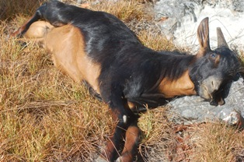

*TAKAMAKA REGION - MALE GOAT SHOT*

**CINQ CASES REGION**

Date: 14th October 2008

Personnel: Alex Underwood, Ritval Pillay

Time of departure: 05:31hrs

J10

* J10 was sighted at 08:44hrs at G.P.S coordinates S09’23.899; E046’30.147.
* The above Judas Goat was seen in the company of J7, J9, J12 and two other Non-Judas Goats.
* They were at a vantage point of 50 meters in semi-open vegetation but unable to make a clear shot because they were all clustered together.
* We even had to climb a Sideroxylon *sp.* tree in order to facilitate our observation and at the same time prevented ourselves from being detected.
* When the whole herd began to move towards us, the Non-Judas Goats were shot at 10:50hrs after they swayed slightly in front.
* The two Non-Judas Goats were found to be females and one of them appeared to be lactating, because milk was oozing from its teats.

CINQ CASES REGION – FEMALE GOATS SHOT

## GOAT MONITORING REPORT - NOVEMBER 2008

## TAKAMAKA GOATS

**Date:** 12th November 2008

**Personnel:** Alex Underwood, Marc Jean-Baptiste

**Time of departure:** 10:05hrs

* Around 10:45hrs while scanning for the Cinq Cases goats accidentally got a strong signal of J8 and that happen at the junction that leads to “Bassin flaman” and “Groove”.
* The goat was moving in the direction of Cinq Cases hut and later divert inland as we press forward.
* At 12:00hrs J8 and J1 were found at Cinq Cases together with another brown Non-Judas goat. They were sighted in the vicinity of Coco transect. The G.P.S coordinates were S09’25.302; E046’30.098
* The Non-Judas goat was too close to the Judas goats hence was unable to shoot.
* The second sighting was at G.P.S coordinates S09’24.312’ E046’30.091 at 13:45hrs and were unable to shoot again as they were moving fast through dense vegetation.
* Thirdly they were sighted again close to Anse Cedres at 15:40hrs at G.P.S coordinates S09’23.372; E046’29.913
* As they were moving into thick Pemphis we had to abandon the activity because we were running out of water.

**Date:** 13h November 2008

**Personnel:** Alex Underwood, Ritval Pillay

**Time of departure:** 07:00hrs

* After finishing the Groove monitoring transect J8 was tracked as there was a strong signal.
* Sighted around 10:26hrs at G.P.S coordinates S09’23.480; E046’29.119
* Unable to shoot because they were under dense shrub making it difficult to differentiate the goats. We had to keep watching them for more than two hours as they stayed at the exact location.
* Two Non-Judas goats were sighted together with J8 and J1 this time.
* Goat was herded further north toward Anse Cedres while following J8.
* Around 13:55hrs at G.P.S coordinates S09’23.296; E046’29.434 tracking was abandoned because the goats moved in thick Pemphis.
* It will be difficult to know the status of Takamaka if J8 and J1 stay permanently at Cinq Cases.

## Cinq Cases Judas Goats

* No tracking was done for J7, J9, J10 and J12
* The trip to Cinq case was made short due to the arrival of the supply boat and DJL/DMM monthly monitoring was not done earlier in November due unforeseen circumstances.
* Another expedition will be undertaken in a week time to remove the remaining Non-Judas goats and locate the J7, J9, J10 and J12.

## Recommendation

* With the situation that had developed twice monthly monitoring will be advisable and also more time will be needed out in the field. Another approach is important to deal with the Takamaka situation.

## GOAT MONITORING REPORT - 21st – 27th November 2008

**CINQ CASES REGION**

**Date:** 22nd November 2008

**Personnel:** Alex Underwood, Marc Jean-Baptiste

**Time of departure:** 05:30hrs

J8 was sighted at G.P.S coordinates S09’23.198, E046’28.993 around 10:20hrs

J8 was seen moving into thick Pemphis with J1, J7, J9, J10, J12 and four other Non-Judas Goats.

Their closeness made it difficult to obtain a clear shot.

The Goats stayed in the thick Pemphis for approximately three hours.

Around 13.00hrs while tracking for J8 we recognized that the goats had moved and latter they were relocated at G.P.S coordinates S09’23.592, E046’28.717 around 14.00hrs. However, as they were continuously moving through thick vegetation no clear shots were possible.

At 17.00hrs we had to abandon the activity as it was getting late. The goats were roughly one hundred meters from us at G.P.S location S09’22.996, E046’29.024

**Date:** 23rd November 2008

**Personnel:** Alex Underwood, Marc Jean-Baptiste

**Time of departure:** 06:30hr

J8 was first sighted at G.P.S coordinates S09’23.592, E046’28.717 around 09:09hrs

The above Judas Goat were seen J1, J7, J9, J10, J12, plus four other Non-Judas Goats

One black male goat was shot but three other Non-Judas Goats escaped into thick vegetation.

J8 was relocated at G.P.S coordinates S09’22.996, E046’29.400 at 09:40hrs with the same group

At approximately 10:30hrs one Non-Judas goat was shot but we were unable to locate the carcass. Several large patches of blood were found which indicated the goat did not survive.

We were unable to determine the sex of the goat killed.

Now only two Non-Judas goats remained with the Judas goats.

**Date:** 24th November 2008

**Personnel:** Alex Underwood, Marc Jean-Baptiste

**Time of departure:** 06:45hr

J8 was seen at G.P.S coordinates S09’23.115, E046’29.030 at 11:30hrs. However, we were unable to establish the number of Non-Judas goats also present.

At 14:25hrs we sighted J8 for the second time at G.P.S coordinates S09’23.625, E046’30.130, but were still unable to determine the number of Non-Judas Goats present as they were moving at speed through the vegetation.

A third sighting was made at G.P.S coordinates S09’23.906, E046’30.273 around 16:30hrs.

We had to abandon the tracking due to tiredness, time of day and because the goats were still moving at speed through the vegetation.

**Date:** 25th November 2008

**Personnel:** Alex Underwood, Marc Jean-Baptiste

**Time of departure:** 06:40hrs

Between 10:30hrs and 16:15hrs J8 was sighted at four different locations. At the fourth location we were able to confirm that no Non-Judas goats were present with

J8 who was found in the company of J1 and J7

It was difficult to view any of the goats as they were constantly on the move.

After tracking J8 we encountered a strong signal for J10 coming from the Anse Cedres direction.

At around 18:00hrs, J10 was sighted with J9, J12 and three other Non-Judas goats at G.P.S coordinates S09’22.968, E046’29.045.

One black female was killed and further tracking was stopped as it was getting late.

Two other Non-Judas goats were still at large.

**Date:** 27th November 2008

**Personnel:** Alex Underwood, Marc Jean-Baptiste

**Time of departure:** 06:25hrs

J10 was sighted at G.P.S coordinates S09’24.131, E046’28.874 around 10:50hrs with J9 and another Non-Judas goat.

The Non-Judas goat (brown male) was killed.

**Overall:**

Special thanks go to Ritval Pillay for his support at the camp. This trip was particularly tough because the goats were roaming over a large area through thick vegetation and the mosquitoes were out in force! While on this G.E.P field trip we encountered two different sites on the coast close to Anse Cedres of an orchid species*.* Alex requires new shoes to continue with the G.E.P as the pair he was using has completely worn out! No photos were added this time as it was accidently deleted on the camera. Also note that 26th November was a resting day for the GEP team.

**Recommendation:**

Since it is very uncertain to evaluate the current situation at Takamaka and in the event that J8 and J1 do not return to Takamaka within two to three months, it would be advisable to look into possibility to transfer two Judas goats to Takamaka. This will surely required the assistance of experts from veterinary section on Mahe, to recapture them. Any other proposition/ suggestions would be greatly appreciated.

## GOAT MONITORING REPORT - DECEMBER 2008

## CINQ CASES REGION

**Date:** 16th December 2008

**Personnel:** Alex Underwood, Marc Jean-Baptiste

**Time of departure:** 08:30hrs

J8

* The above Judas Goat was sighted at G.P.S coordinates S09’23.705, E046’30.236 around 12:30hrs
* J8 was sighted in the company of J1, J10 and J7
* All the Judas goats were travelling in the same direction but sporadically spread, hence it made our task very difficult to be certain if there were other Judas present.
* There were no other Non-Judas Goats spotted this time.
* J9 and J12 were not sighted on this trip.

Overall:

The GEP was conducted for one day only as logistics and experienced staff had to be diverted with the Insect group, Filming crew and the Pond Heron Project. Marc’s shoes were damaged on this trip. Alex was having difficulty walking as he was wearing smaller shoes than normal and at the end of the day his feet was aching.

Christina Quanz is currently plotting the GPS points on an Aldabra map into the GIS system.